Introduction to A-level Photography Quiz Q1: What is the etymology (origin & history) of the word photography?
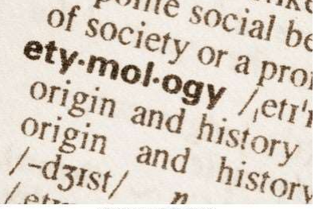

Answer- painting with light

Q2: What year was the first photograph made in camera?
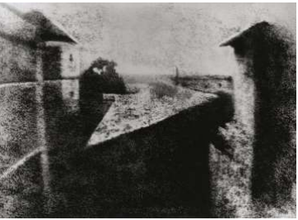
Answer-1826 (Joseph Nicéphore Niépce)

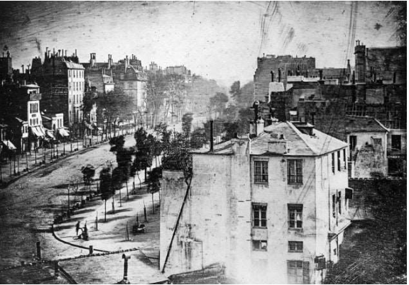
1838 (Louis-Jacques-Mandé Daguerre)
Q4: Who made the first 'selfie'
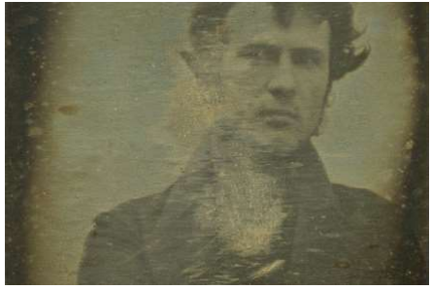
Robert Cornelius (1839)
Q5: When did the first colour photograph appear?
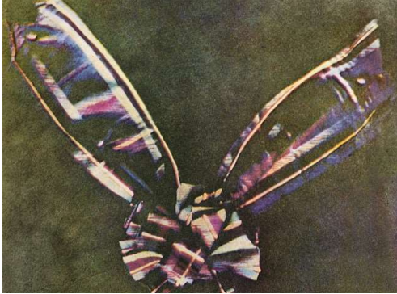
1861 (James Clerk Maxwell)

Q6: What do we mean by the word genre?

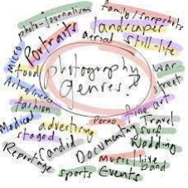
A style or category of art

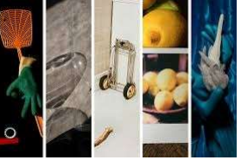

An image that shows inanimate objects from the natural or man-made world.

Q8: What was the main purpose of the Pictorialist movement?


