Q1: What is the etymology (origin & history) of the word photography



Writing with light

Q2: What year was the first photograph made in camera?

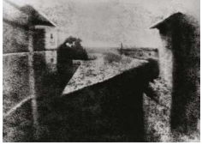

1826

Q3: When did the first photograph of a human appear?

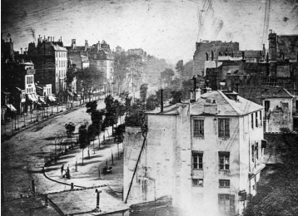

1838

Q4: Who made the first 'selfie'

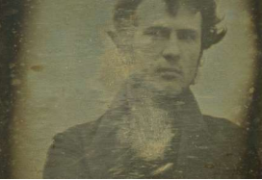

Robert Cornelius (1839)

Q5: When did the first colour photograph appear?

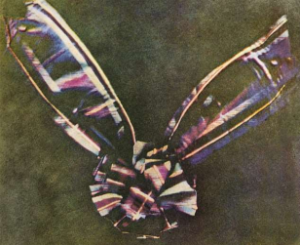

1861

Q6: What do we mean by the word genre?



A style or category of art

Q7: What do we mean by the genre of still-life?



An image that shows inanimate objects from the natural or man-made world

Q8: What was the main purpose of the Pictorialist movement?

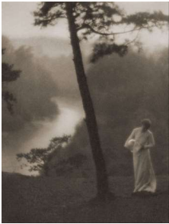

To affirm photography as an art form

Q9: How do we describe the term documentary photography?

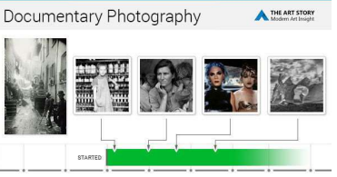

Capture images that truthfully portray people, places and events.

Provide in-depth information about a subject over a long period time.

An interpretation of reality as witnessed by the photographer.

Q10: What is exposure in photography?

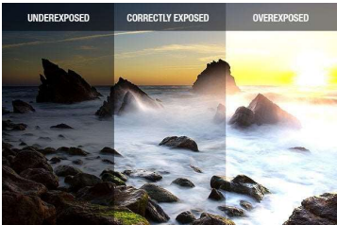

The amount of light that reaches your camera's sensor

Q11: What controls exposure on your camera?

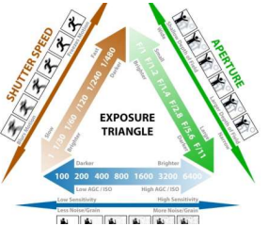

Aperture, shutter speed, ISO.

Q12: What control on our camera records moving objects?

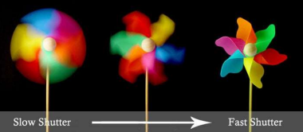

Shutter

Q13: How do we explain depth of field?

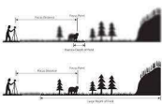

How much of your image is in focus

Q14: What factors affect Depth of Field?



Lens aperture, distance from camera to subject, and lens focal length

Q15: What is composition in photography?

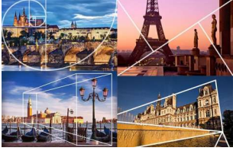

The arrangement of visual elements within the frame.

Q16: What is your understanding of aesthetics in art?

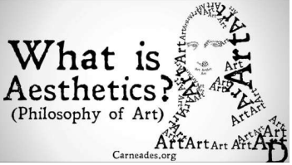

Concerned with the nature of beauty and taste.

It is subjective and in the eye of the beholder.

Aesthetic qualities refer to the way and artwork looks and feels.

Making a critical judgement based on observation and understanding

Q17: What are contextual studies in photography?



To provide historial, cultural and theoterical understanding of images

Q18: How many images are captured on average every day worldwide?

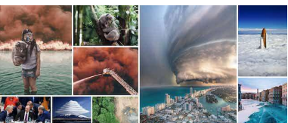

4.7 billion

Q19: Which portrait is the most reproduced in the world?

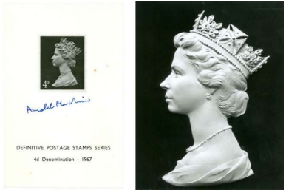

The Queen (Elizabeth II)