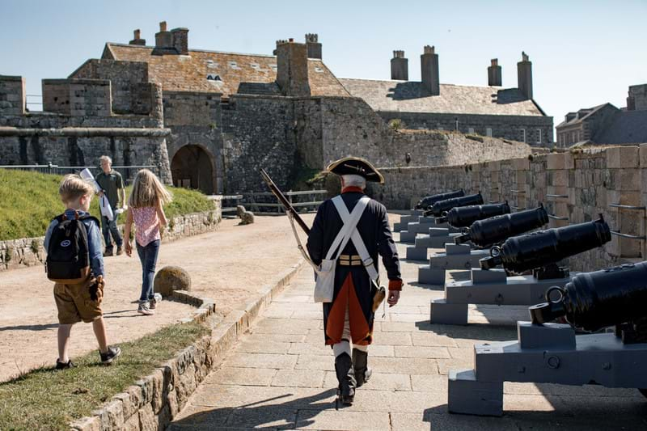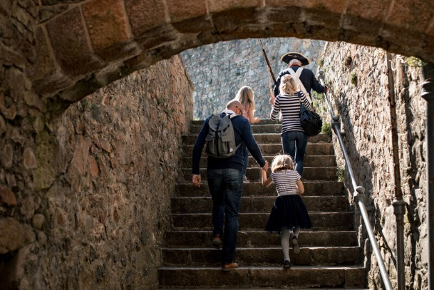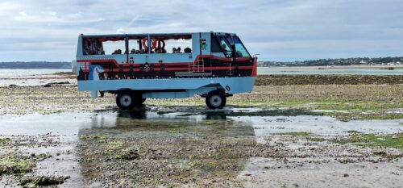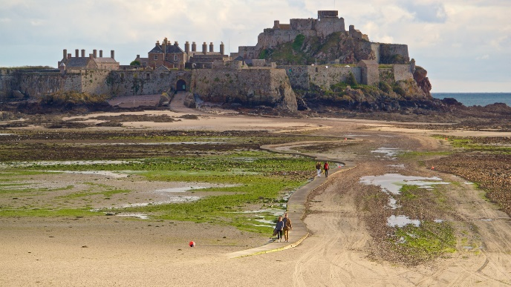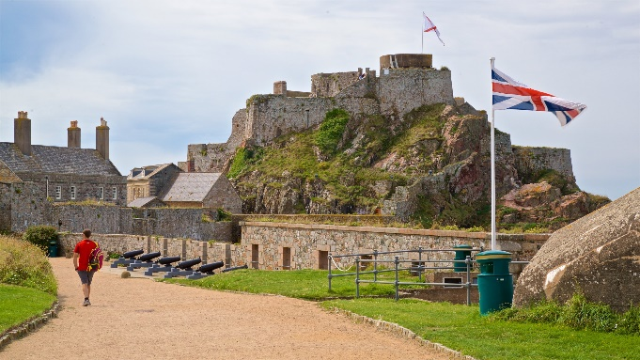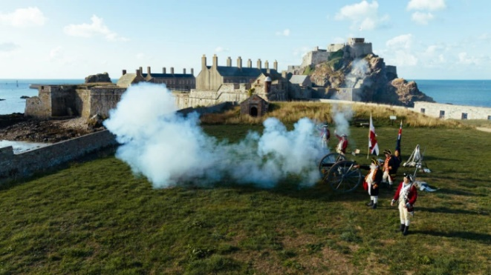

CONTINUED POV SHOTS OF EXPERIENCE AT THE CASTLE AS WELL AS MLS SHOTS

MEDIUM/OVER THE SHOULDER SHOT TO SHOW OUR WAY OF TRANSPORT TO THE CASTLE

SERIES OF MEDIUM SHOTS AND POV SHOTS ACROSS THE CASTLE TO ESTABLISH STORYLINE OF THE FILM

ESTABLISHING SHOT - DISTANCED XLS OF ELIZABETH CASTLE TO INTRODUCE SUBJECT OF FILM

MIXTURE OF HIGHER ANGLE, POV, MLS OF THE CANON FIRINGS AND THE GUNSHOTS

LOW ANGLE SHOT OF TOURISTS - CREATE RANGE OF SHOTS



Shot No.

Scene No.

Shot No.

Shot No.

Scene No.

Shot No.

Scene No.

Shot No.

Scene No.

Shot No.

Scene No.

Scene No.

Title:

Page: