**'How can photography bear witness to reality?’**

**INTRODUCTION**

*“Photographs are a way of imprisoning reality … One can’t possess reality, one can possess images – one can’t possess the present but one can possess the past* [1.](https://www.goodreads.com/quotes/195221-photographs-are-a-way-of-imprisoning-reality-one-can-t-possess-reality)*”- Susan Sontag*

Documentary photographers take an approach to attempt to witness and capture the reality of the events of the world, possessing rawness and authenticity.Photography can act as evidence and testament to a specific event or historical moment. One of the central principles of the documentary aesthetic was that a photograph should be untouched, so that its authenticity, its veracity and genuineness might be maintained. Photographs can even serve as catalysts for change, fostering sympathy and raising awareness or, alternatively, offer critical commentary on historical people, places, and events. Throughout the history of the medium, photographers have aimed to capture the essence of events they witnessed—though the question of the trustworthiness of their images is always up for debate. Therefore, I believe the way the events are documented are dependent on the photographer's narrative: the objectives behind their work, their perspective of these events, and how they aim to capture the moment due to the motives surrounding this.

Photography’s relationship with reality has been fraught from its very invention as the photograph itself as a document is real but what the image depicts is only a representation of reality. This opens up the image to all forms of manipulation. Susan Sontag relates the belief in a photograph's ability to capture 'reality' to the development of certain human practices. Since a picture confers on events *“a kind of immortality (and importance) it would never otherwise have enjoyed,"* she explains, the act of taking photographs has become essential to the experience of world travel. The possibility of 'true' photographs leads to a compulsion to *"convert experience into an image"* to *"make real what one is experiencing."* Susan Sontag explains photography in comparison with Platos Cave where reality is limited to only what is inside the cave where shadows of the outside world reflect only pieces of the truth. Today, photographs are also pieces of the truth, they only show a part of the whole and they are only one person or one photographer's perception. We are shown hundreds of photos everyday where we don’t know the people in them or the intentions behind them, but we create an idea of the reality behind it through a single image and interpretation. A photograph can be a physical object, a reflection of reality, but also a manipulation and mere image of the truth. It can be manipulated in many ways, but because it claims to capture reality, too many times we regard an image as the whole truth and forget that even a photograph is an interpretation of what someone else sees or feels. In the modern world, photography, as Susan Sontag explains, has become many things; it is an art form that is also a social right, a defence against anxiety, and a tool of power. Sontag challenges the ‘presumption of veracity’ associated with photographs, arguing that they *are "...as much an interpretation of the world as paintings and drawings are."* She describes the role of the photographer in determining the exposure, light, texture and geometry of a photograph. Photography is a means for capturing reality (which is considered unobtainable) by freezing it. You cannot hold reality, but you can hold a photograph. Photography is not only a way of preserving the past, but also a way of handling the present. Sontag also argues that through repeated capturing and viewing reality through photographs, their subjects can become less real. She claims that *"aesthetic distance seems built into the very experience of looking at photographs,"* and also that the sheer volume of horrific images throughout the world has produced a *"familiarity with atrocity, making the horrible seem more ordinary – making it appear familiar, remote … inevitable* [2](http://www.lab404.com/3741/readings/sontag.pdf).” This suggests how desensitisation is another factor disrupting the effectiveness of photography capturing reality.

Furthermore, Roland Barthes notes that the human subject can be made less real through the process of being photographed. He notes, *"Once I feel myself observed by the lens, everything changes: I constitute myself in the process of 'posing', I instantaneously make another body for myself, transform myself in advance into an image."* This clearly outlines how it is not only the photographer's manipulation of reality that can disrupt its objectivity, but also the subject's interaction with the camera, and how viewers interpret the image. Additionally, Tom Gunning points to the physicality of the camera as a mediator between the photograph and reality. He notes that the use of a lens, film, a particular exposure, kind of shutter, and developing process *"...become magically whisked away if one considers the photograph as a direct imprint of reality* [3](https://en.wikipedia.org/wiki/Truth_claim_(photography)).” Thus, introducing the role of digitalisation and editing processes after the moments have been captured that can interfere with bearing witness to reality.

As examples of images that have beared witness to the reality of historical events I will be analysing the work of Dorthea Lange and James Nachtwey, to uncover how these artists attempt to capture reality through their documentary work, and whether this is ever truly achievable. In my personal study I will be exploring the personal, social, political and economic impacts of the outbreak of the coronavirus, and demonstrating how, utilising documentary techniques, I am able to capture this shift in our social norms, routines, the ways of life and daily occurrences that have been transformed as a key historical moment whilst it is occurring. Therefore, clearly witnessing and recording the reality of the event of the pandemic. However, I will be telling the story of the pandemic through my perspective of being an insider immersed into, and also affected by the coronavirus restrictions and changes and thus the way I record this event may differ from the way others may be recording it. Throughout my study, I have explored many aspects of the contextual consequences the coronavirus has created: with my visual responses focusing on my personal experiences with my sister testing positive, and becoming ill from the virus, alongside the shifts in society's norms, making the familiar become unfamiliar.

The impact and restrictions of the coronavirus: being contained in lockdown, isolation, and restrained within the boundaries of our houses with minimal contact has entirely transformed and rebelled against our society. Humans are social species, we enjoy interacting with others: gathering, celebrations and being close to others is what helps us to survive. Therefore, this sudden switch in the rules of society has been extremely different to what we have ever experienced. If you don’t wear a mask in public, you are now deemed as socially unacceptable- something we never even considered to be an expectation in our Western world. Not being able to attend our usual work, school and social events whilst life is put on hold is a complete rebellion against what we are familiar with.

All these consequences that coronavirus raises, alongside this personal and social impact being discussed in my work, such as the substantial economic recession, rapidly rising unemployment rates, increasing rates of suicide from the isolation, and burden on health care workers as they are stretched to their fullest, clearly demonstrate the significance of this pandemic as a global issue of the century. Therefore, adding onto a timeline of other substantial moments like World Wars, The Great Depression and Human Rights Injustice. Consequently, through my photography I am recording an insight into the ways that life has shifted in a realistic and documentary style manner as a record that could be reflected on in years to come. The pandemic is a story we will tell our future grandchildren, and I believe that photographers can use their cameras in order to provide evidence and a documentation of these key events.

**PARAGRAPH 1: HISTORICAL CONTEXT**

The idea of bearing witness to the ways of life and events of the world emerged in the early 20th century with the creation of Straight photography as an antidote to Pictorialism’s softly focused and staged images. Shortly after photography’s invention in 1839, rapid and succeeding technological advancements allowed photographic [images](https://www.moma.org/learn/moma_learning/glossary/#image) to be adopted as memory aids, surrogates for direct observation, and even trustworthy duplicates of important documents. Documentary photography refers to a type of sharp-focus imagery that captures a moment of reality, in order to convey a meaningful message about what is happening in the world. Documentary photography typically focuses on an ongoing issue (or story) which it relates through a series of photographs, and are typically designed to draw public attention to real-life situations which, in the opinion of the photographer, require urgent remedial action 4. Straight photography emphasizes and engages with the camera's own technical capability to produce images sharp in focus and rich in detail, and depict the scene or subject as the camera sees it [5](https://gemmaephotography97.wordpress.com/2016/01/28/art-movement-straight-photography/). Realism has claims of having a special relationship to reality and its premise, that the camera's ability to record objectively the actual world as it appears in front of the lens unquestioned.

These forms of photography clearly have the objectives of bearing witness to the reality of key historical moments and events: social reforms, war, political corruption, economic disruptions and environmental problems. The objectivity of a photograph is as important as its realism being used to represent social, economic and political issues to provide clear representations of reality. Key photographers within these movements capture significant moments in history that have formed how society and the government deal with certain situations and contributed to social reform overtime. For example, some of the earliest photography documentaries occurred during the American Civil War; following on to the turn of the 20th century which was marked by rapid industrialization and urbanization in the United States; the Industrial Revolution, which created many less glamorous issues for photographers to document, and photographers used their lenses to focus national attention on these social injustices. As public sentiment solidified against these practices, laws changed, and working conditions improved. Like the Civil War before it, World War I catalysed documentary photographers to share the carnage of war with the rest of the world, and the Great Depression that resulted from the stock market crash of 1929 blighted much of the western world [6](https://en.wikipedia.org/wiki/Documentary_photography.). Photographers used their power to document the poor and suffering, and the hungry and despondent. To this day, some of the most famous documentary pictures came from the Depression Era such as those by Dorothea Lange and Walker Evans.

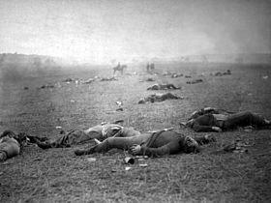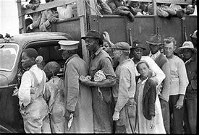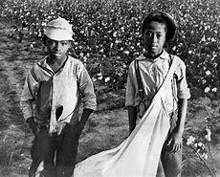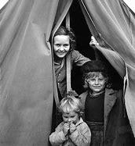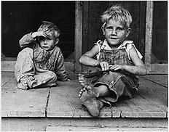

Max Pinkers, a photographer and academic explores the challenge of documentary photography’s relationship to reality. “*Haunted by a crisis of faith in its authenticity, the documentary genre is continually trying to re-position itself in relation to today’s excesses of a post-truth ideology and blurred frames of realism* [7](https://americansuburbx.com/2018/07/max-pinckers-interview-speculative-documentary.html.).” Pinkers prefers to use the term ‘speculative documentary’ as he believes that the documentary attitude, critical method, or gesture, is a way of coming to terms with reality – a way of doing, engaging and creating that embraces the multiple and mutable realities of our world. Pinkers has always experienced the documentary space as a hybrid one, where different approaches can come together in different forms. He suggests that the creation of an image can shift fluently from a performative or theatrical act into a sculptural intervention, contextualized by found documentation, embedded into a socially constructed narrative. Above all, he states that it is a space in which images are conscious of their own deceptive nature and have the ability to critically question themselves. The documentary should openly embrace its limitations and continuously challenge them, doubting and speculating over our mediated relationship to reality when attempting to represent it through images and narrative. Haunted by a crisis of faith in its authenticity, the documentary genre is continually trying to re-position itself in relation to today’s excesses of a post-truth ideology and blurred frames of realism. How can we be inspired by the paradox of attempting to approach reality with a documentary attitude while it continuously mutates and evaporates? How can documentarists deal with their own positions and pareidolia? Pinkers summarises “*It’s not about whether reality exists, but rather about whether the audience agrees with you that what you are showing them is an honest attempt to represent reality, or to reflect about the awkwardness of this attempt. Our so-called realism today is fundamentally born out of a political age, an age in which people believed that politics could not only understand the world but could also change it. Documentaries were born out of that political ideal. This agreed frame of realism in today’s world has deteriorated to the extent that there is no general consensus about what is real, what is fiction, half-truth, or opinion.”*

Through my own images in response to coronavirus I aim to explore photographic approaches to straight photography, realism and documentary both aesthetically and conceptually. Exploring concepts surrounding the change in social norms and everyday life is not staged or tableaux, it is reality, this is actually occurring in school, in my family, and in public places. I strongly believe that taking the opportunity to document this from a candid approach is crucial to capture how our routines have been disrupted due to the ways of life from the outbreak of the pandemic, and therefore I feel that photography can be used to enable us to do this: especially in the form of documentary approaches. I am discussing how representing these issues through visual representations it allows us to record key events of the world, but perhaps photographs began to introduce subjectivity where the photographer is capturing visual representations of a person’s deeper emotions of these global events, and that photograph could be interpreted differently by different people. For example, in my work I am taking an inside perspective as it is happening, within my day to day routines and shifts in life. Photographs are also being used as persuasion, where mass media is publishing images of different levels of objectivity based on the photographer’s own interpretation and perhaps to a lesser extent political motivation towards the world they are capturing. My motives behind my documentary approach and visual diary are to be kept as a record of this unprecedented period from a personal perspective, whilst perhaps other photographers capturing this story may take an alternative approach, such as by focusing on the medical side and impact on health care workers within the NHS.

Giles Duley states, *“Documentary photography has always come with great responsibility. Not just to tell the story honestly and with empathy, but also to make sure the right people hear it* [8](https://www.brainyquote.com/quotes/giles_duley_559497)*.”* This reinforces my viewpoint that whilst capturing these key global issues, there may be an element of subjectivity to the way they record these events; unconsciously manipulating how the issues are portrayed due to their motives, position to the subjects, and objectives of what the publication of their images will lead to. In contrast to this, Henri Cartier Bresson highlights that photography does have an ability to bear witness to reality in an objective manner. His concept of the “decisive moment” – a fleeting meaningful instant captured by the camera – shaped modern-day street and documentary photography. Cartier Bresson outlines, “*To me, photography is the simultaneous recognition, of the significance of an event as well as of a precise organisation of forms which give an event it’s proper expression* [9.](https://www.theartstory.org/artist/cartier-bresson-henri/)” He never used the darkroom to adjust his photos, to remove the manipulation of the editing process from distorting his images relationship to reality. He focuses on the concept of photography and time through his approach of freezing a moment, and thus claiming that through his work he is able to bear witness to truth through spontaneity and candid techniques. Consequently, it is clear that some photographers attempt a more objective narrative which clearly depicts reality illustrating how this art movement can be truthful.

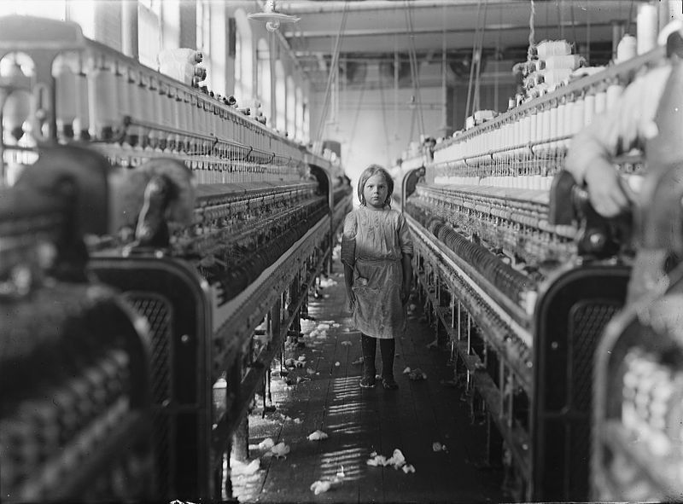 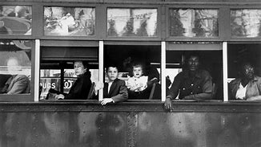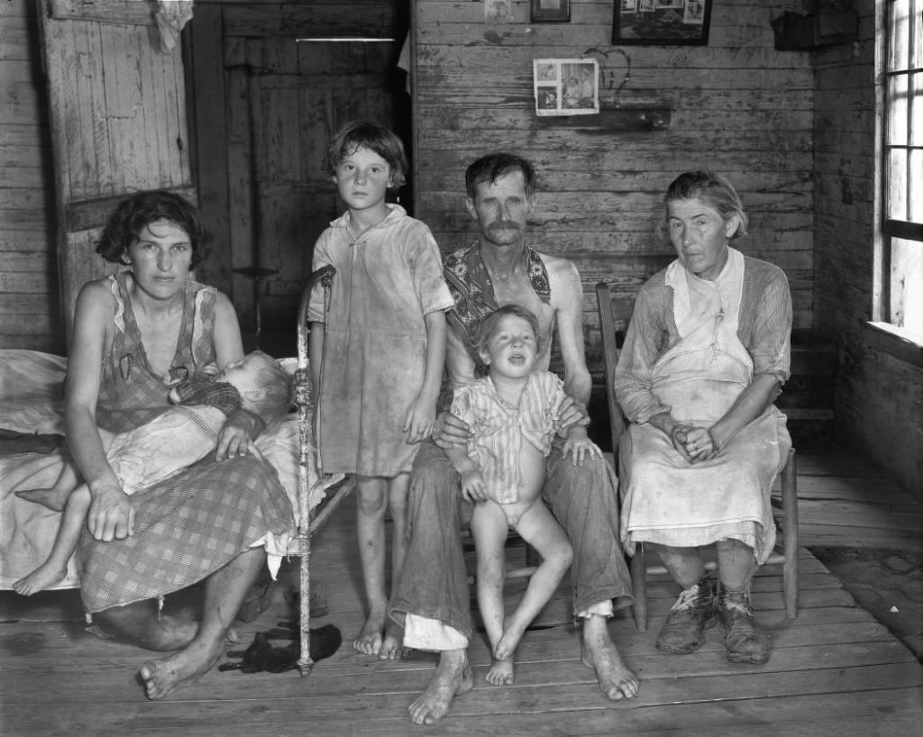

**PARAGRAPH 2: ARTIST REFERENCE ONE**

Dorothea Lange is one inspirational documentary photographer who clearly attempts to bear witness to reality by capturing events of the world throughout her work. She believed in photography’s ability to reveal social conditions, educate the public, and prompt action. After the stock market collapsed in 1929, Lange felt she had to respond to the deprivation she observed first-hand on the street near her home in San Francisco, where she had a prosperous portrait studio. Her first social documentary photographs depicted striking laborers and bread lines in 1933. In 1935 the federal government formed the Resettlement Administration (later renamed the Farm Security Administration) that oversaw a variety of programs that attempted to alleviate rural poverty. Dorothea Lange and others including Walker Evans, Arthur Rothstein and Gordon Parks worked for the historical section of the FSA. Their goal was to create and promote a record of America during the Great Depression, in part to help explain and justify the need for government spending on New Deal programs. They documented the ravaged landscape of the dust bowl and the plight of migrant workers and the unemployed. Stryker assigned the photographers basic subjects to photograph such as food, home, leisure, the work environment, religion, transportation, and commerce. The photographers also collected notes in the field that were used to create captions for the images. It was hoped that Lange’s powerful images would bring the conditions of the rural poor to the public’s attention. 10

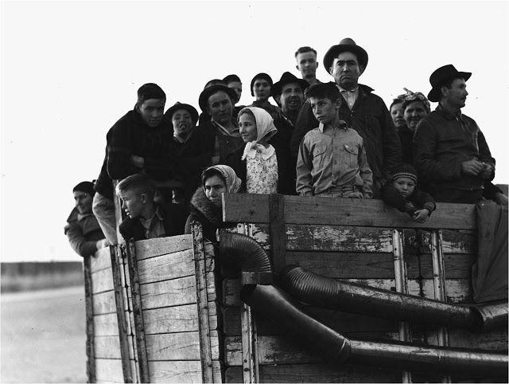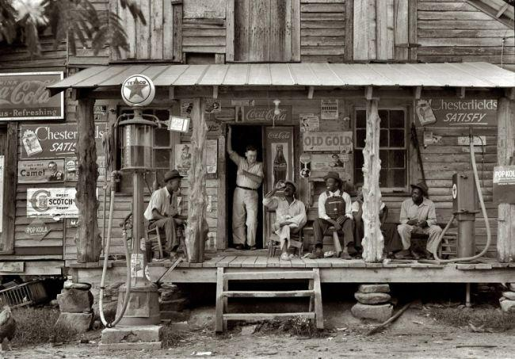

Lange's photographs influenced the development of documentary photography and humanized the consequences of the Great Depression. In the depths of the worldwide Depression, 1933, some fourteen million people in the U.S. were out of work; many were homeless. During the decade of the 1930s 300,000 men, women, and children migrated west to California, hoping to find work. She roamed the byways with her camera, portraying the extent of the social and economic upheaval of the Depression. This key event was a worldwide economic crisis that first occurred in America, and was the longest economic depression of the 20th century [11](https://en.wikipedia.org/wiki/Great_Depression#:~:text=The%20Great%20Depression%20was%20a%20severe%20worldwide%20economic). Lange’s approach to her work, especially in her collection of images from The Great Depression thus successfully demonstrates how she was attempting to capture the impacted subjects from this crisis as it was occurring, giving an insight into the poor conditions they were living in to raise the issue and make a difference. She supports how photographers use the camera to bear witness to real events and also as a method raising awareness of global issues, at a time in the Great Depression Era where society were not aware what was happening in other parts of the world, mainly due to the lack of television or news, and thus this documented and spread the recognition. This effectively demonstrates that Lange uses her camera to document key events in the world, but the motives and instructions being associated with the FSA clearly demonstrates that while capturing these moments, the predetermined objectives for the images may alter the way the stories are described in truth. Photography can be used as a propaganda tool to represent a particular point of view or support a dominant ideology. In this case, capturing the desperate condition of the rural poor was emphasised to persuade the government and society to enforce changes and help to stop the suffering.

I have found her inspirational for my personal study as she captures key historical events in the past, linking to how I am aiming to discuss the issues around the coronavirus pandemic in the present day. The coronavirus has also caused an economic crisis worldwide due to the lockdown restrictions, fall in demand for business and rapidly rising unemployment rates, leading to the associated effects on society as they are left suffering with minimal income, trying to provide for their families. Consequently, I believe there are clear links between Lange’s contextual messages and issues she is capturing in her work in the past, and what I am capturing in our current society in my personal study. It is a ground breaking shift from the norm that we are used to in both crises.

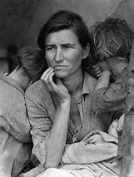

In Lange’s most iconic images, Migrant Mother, she captures one of the key subjects impacted by the Great Depression with a social motivation to bring attention to the struggles many were experiencing. We can look at the photo as an iconic representation of true American grit in the face of adversity. But a photograph that also performs an act of transformation; it takes a moment fluid in time and fixes it into a timeless image. Thus, Lange’s photo has turned an impoverished woman (who only much later was identified as Florence Owens Thompson) into an object — whether of admiration, pity, or fascination — for the consumption of a more affluent public. The visual aesthetics of this image questions the true objectivity in its creation 12. Although Lange is bearing witness to the reality of the Depression Era and using the Migrant Mother as a symbol of the suffering nation, the overall outcome is carefully constructed. Thus, raising the concept that documentary photographers may capture key events, but it is often from their personal narrative: how they are aiming to tell the story are the motives behind this.

*"I saw and approached the hungry and desperate mother, as if drawn by a magnet. I do not remember how I explained my presence or my camera to her, but I do remember she asked me no questions. I made five exposures, working closer and closer from the same direction. There she sat in that lean-to tent with her children huddled around her and seemed to know that my pictures might help her, and so she helped me. There was a sort of equality about it.* [13](https://en.wikipedia.org/wiki/Dorothea_Lange.)”

Dorothea Lange's goal as a photographer was to show another side of poor people, she wanted to show "*their pride, their strength [and] their spirit*". And this image does just that. It is apparent that the mother has been through a lot but there is still a spark of hope that is portrayed as she keeps her head up high, hoping that things will get better. Lange sent this image to a newspaper to expose how people were living and soon after food was sent to these suffering people. A majority of the space in this photo is taken up by the mother’s pyramidal shaped body. Her children are on either side of her, which frames her figure in a way that again draws attention to the mother, proving that she is the subject of the photo. The black and white manipulation to the image reinforces my belief of how Lange aimed for this photo to be interpreted: the harsh black and white tones enhances the intensity of the image, creating a juxtaposition between the light and dark shades, with the light source illuminating the mothers face to draw the viewer to this centre point. The overpowering emotion and pain depicted by the mother as well as the rawness and sincerity in her face, it allows one to believe that this image conveys such sincere emotion as someone who is actually going through something so horrific. Therefore, proving that this image is a depiction of real life and not some made up scene, bearing witness to the Depression Era. The mother’s children positioned facing away from the camera lens also contribute to this: their feelings of uncertainty, a lack of support, and fear due to their situation allows Lange to humanise the Depression Era through her narrative.

The FSA photographers knew that in telling the stories of their time, they needed to create images that would impact and appeal to the emotions of viewers. This project was in part a public relations campaign. Toward this end, the photographers and editors often selected subjects and images that would garner wide public appeal and sympathy at a time when America was very segregated by race and class. This is likely a factor in why images such as Migrant Mother, which depicts a (seemingly) ‘white’ woman, who is identified as a widow and mother, became icons of the era. Ironically, the woman in this image, Florence Owens, was later identified as being Native American. The FSA photographers also sometimes arranged people or details within the scenes that they photographed to create more powerful compositions 14. This raises questions about the truthfulness of documentary photographs bearing witness to reality. Can we question if Lange might have given some direction to the woman and children depicted in ‘Migrant Mother’, such as might Lange have asked the woman to place her hand on her chin or asked the children to turn their heads away from the camera? This emphasises on the point that there is always going to be an opinion behind the camera, an individual which is going to interpret their situation due to their beliefs, experience and upbringing.

When viewing ‘Migrant Mother’ from a social or historical document perspective, the picture appeals to emotional empathy (a worried mother is shielding her children) and it reflects a humanitarian notion of universal similarities in the condition of humankind. Overall, it represents a universal symbol of motherhood, poverty and survival. In relation to politics and ideology, the photographers working for the FSA agency were given shooting scripts and had no control over how their pictures might be cropped, arranged, captioned or used. Their position was similar to a modern-day photojournalist working for the commercial press and news media and the FSA project had a clear political purpose in recording statistically the position of the rural poor. Moreover, the caption ‘Migrant Mother’, conforms to the transcendent ideal of mother and child and symbolises a universal concept of motherhood and humanity (a nurturing and caring mother). As a gendered image, feminist photo-historians have commented upon Lange’s own gender and often referred to her as the ‘mother’ of documentary photography – being one of the first women to follow this tradition. It has been argued that her gender made her pictures, particularly of other women, more ‘compassionate’. Representations of femininity played a crucial role in the rhetoric of the FSA photographs, both in terms of the gender of the photographer and subject-matter. Lange drew on traditional, such as Renaissance depictions of the Virgin and Child, and the close cropping of the image creates within the frame itself a protected, interior, feminised space. All these factors being discussed highlights the difficulties in bearing witness to reality in photography. Social, historical, political, ideological, gender issues and text all interact to distort the reality of the image based on each of their motives, and how photographs can be understood through different perspectives.

The question of the reality of ‘Migrant Mother’ is further exemplified when we consider the way in which Lange constructed the iconic image. *“Lange asked the mother and children to move into several different positions. She began with a mid-distance shot. Then she backed up for one shot, then came closer for others. She moved aside a pile of dirty clothes (she would never embarrass her subjects). She then moved closer yet, focusing on three younger children and side lining the teenage daughter out of the later pictures altogether* [15.](https://expertphotography.com/susan-sontag-on-photography-quotes/)” These alternative encounters represent a much richer set of human interactions between the five people in the photos and the photographer. This suggests that in the process, Lange altered ‘Migrant Mother’ for aesthetic reasons, filtering out elements of the scene to capture in detail what she wanted to focus on after experimentation. Thus, manipulation of form, consciously or unconsciously, disrupts the notion that photographers bear witness to the entire reality. With the narrative based around the hardship and poverty to connote the wall street crash, the tyranny of capitalism and the ongoing divide between the rich and the poor, Lange uses the detailed portrait of the mother’s struggling face as a way of symbolising this.

**PARAGRAPH 3: ARTIST REFERENCE TWO**

James Nachtwey is another key documentary photographer like Lange who attempts to bear witness to the reality of the events of the world through his documentation of a variety of armed conflicts and social issues. Spending time in [South Africa](https://en.wikipedia.org/wiki/South_Africa), [Latin America](https://en.wikipedia.org/wiki/Latin_America), the [Middle East](https://en.wikipedia.org/wiki/Middle_East), [Russia](https://en.wikipedia.org/wiki/Russia), [Eastern Europe](https://en.wikipedia.org/wiki/Eastern_Europe), the former [Soviet Union](https://en.wikipedia.org/wiki/Soviet_Union) shooting pictures of war, conflict and images of socio-political issues in [Western Europe](https://en.wikipedia.org/wiki/Western_Europe) and the [United States](https://en.wikipedia.org/wiki/United_States). Nachtwey believed that the stories the photographers told were in complete contradiction to the stories the political and the military leaders told the world. He wanted to be of help somehow; he chose photography. He started his career as a war correspondent and a war photographer but later in his life, he turned to social issues especially forms of deadly diseases, poverty, and starvation. James has a very high opinion of photography as a means of communication. He believes photography not only records history but also helps change its course. Photography makes the change not only possible but also inevitable. [16](https://www.aperturebuzz.com/james-nachtwey-war-photographer/)

*"I have been a witness, and these pictures are my testimony. The events I have recorded should not be forgotten and must not be repeated* 17."

In his opinion, documentary photographs give the victims of war and the citizens a voice in the outside world, a voice that they wouldn’t have otherwise. As a reaction, it stimulates public debate and awareness. Nachtwey attempts to be a part of the conflicts he captures; I believe this has clear links to my immersive approach when capturing the pandemic as it is also something that I am being impacted by as an insider: as opposed to photographing something from an outward perspective that is less personal and insightful. Moreover, like Dorothea Lange, James Nachtwey focuses his work on key impactful events and how they affect different members of society like the coronavirus has, which is inspirational for my contextual messages being communicated in my personal study.

“*Images are one of the means by which people remember history. In many ways a photographic image is the first thing that enters one’s mind when we think about a historical event that occurred since the invention of photography. Photographs show us the reality on the ground* [18.](https://www.aperturebuzz.com/james-nachtwey-war-photographer/)” This quote suggests that Nachtwey clearly believes through his work, photography is one of the few ways we can record events from how they actually happened, capturing an instance of raw reality.

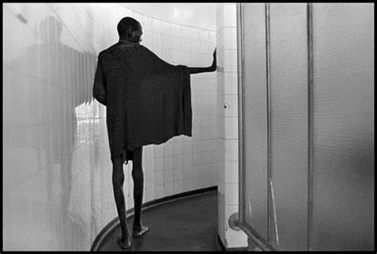

This image is an example of Nachtwey’s project on patients suffering with AIDS, taken in Zimbabwe, 2000 - In a tuberculosis ward where the great majority of the patients suffer from AIDS. The composition of the subject: facing away from the lens, highlighting his wasted, skeleton body frame, which is reflected on the wall behind, suggests the subject perhaps was oblivious to Nachtwey’s presence. The subject is stood alone in the centre of the frame: symbolising the loneliness and helplessness of his condition, suggesting how there has been a lack of awareness and support to treat the patients suffering from this disease, and thus linking to Nachtwey's aims behind his work to capture this suffering. His lack of clothing, stood bare feet, further reinforces the poor condition and poverty, with insufficient resources that contributed to his illness. Moreover, the atmosphere and bleakness created coincides with the dark theme, and the black and white filter helps produce this ghostly environment that produces ideas of death and pain. In his photographs, it is clear that he is attempting to document the conditions of a given situation and what effects those conditions are having on the people who are enduring them.

“*I work in the moment. It's a personal reaction to what I'm seeing. There's no template. My pictures are not intended to confirm what I already know. The process of photography is a way of exploring reality in real time, and real space. Everything is a result of an improvisation. If beauty does exist or coexists with tragedy, it's part of life, not something I or any other photographer is imposing* [19](http://www.photosensibility.com/2008/12/22/james-nachtwey/).” Nachtwey suggests that the aesthetics of his images have not been subjected to any bias from his angle, editing or composition in this quote. He is stating that his work just holds a moment in time that he observed in still and therefore he believes that his images can successfully bear witness to the events of the world in a truthful manner. However, there is always the question that does, perhaps Nachtwey’s social motivation unconsciously disrupt the objectivity of these real moments in an exaggerated way? The question is about how meaning is constructed.

Contrary to Nachtwey’s explanation, there is still an ongoing debate on whether Nachtwey’s work is a true depict of reality when photographing these wars, poverty and illnesses. In the image above, the black and white effect is a clear example of this: Nachtwey has clearly manipulated his outcomes after the images has been taken to remove the original, true colours and instead creates more abstract outcomes because of this. Nachwey has been criticized for aestheticizing these victims of the events he records. Beauty is a vexed matter in scenes of suffering, cruelty and death. Nachtwey’s photography is artistically beautiful as there is an underlying tone of romanticism which is portrayed in his images. This suggests his inability to be entirely truthful which subsequently effects the reality of his images as he is manipulating them to show situations which are more beautiful than what he experienced in reality. Therefore, his representations of global issues and wars are not entirely honest to reality. Nachtwey somehow finds the beauty in his anguished subjects and this subjective nature to want visually aesthetic images is destroying the reality of the situation which he experienced and should have been capturing. Nachtwey’s social motivations to raise awareness and bring change through his work could suggest how, as he wants the message to be powerful, he felt he needed to create eye catching images. However, they must not be aesthetically composed otherwise this takes away from the message and impact of the subject. Additionally, Susan Sontag states, *“Beautiful photographs drain attention from the sobering subject and turns it towards the medium itself, thereby compromising the pictures status as a document.”*

Abigail Solomon-Godeau, an American art historian, explores in depth the effects of the inside/outside approach. Her essay ‘Inside/Out’ thoroughly considers how being an insider compared to being an outsider may have different impacts on the representation of images. This can be linked to photography’s ability to bear witness to reality and how it can affect the objectivity of images capturing key global issues from a documentary approach. Solomon-Godeau says that insiders produce more realistic images as they are experienced in that area. She states “The insider position – in particular context, the “good” position – is thus understood to imply a position of engagement, participation, and privileged knowledge, whereas the second, the outsider’s position, is taken to produce an alienated and voyeuristic relationship which heightens the distance between subject and object [20.](https://www.photopedagogy.com/uploads/5/0/0/9/50097419/week_5_abigail_solomon-godeau_inside_out.pdf)” They are outsiders going into areas of global issues, creating an opinion of what they interpret the situation as being. An outsider is more likely to exploit them and represent the situation falsefully. Therefore, how can an individual in the “position of total exteriority” represent the reality of suffering objectively?

Abigail Solamon-Godeau’s arguments can be used to critic James Nachtwey’s work of representing wars and global issues. Nachtwey is essentially an outsider and a figure of exteriority in the areas of key events such as war which he focuses on. Therefore, after consideration of Solamon-Godeau’s arguments we portray his images to be subjective because he is looking at a situation which is not natural to him, as it is not directly affecting him. However, Nachtwey takes a longitudinal approach to his projects by travelling, working and being amongst the events he captures, which may have transformed him from being an outsider into an insider. Consequently, this could suggest that Nachtwey is able to be more objective as a photographer and follow closer to the principles of straight photography capturing what the camera immediately sees rather than what his mind’s eye is seeing. For example, Nachtwey has been injured and faced near death experiences when capturing significant moments in history like the 9/11 horror, and demonstrates his immersive approach into his work, living in the moment whilst capturing his images which suggests it is more representative of bearing witness to reality. Overall, Abigial Solamon-Godeau states, “In all the examples given there is always a photographer, someone who selects the angle of the view, the subject, the medium…” Here she emphasises on the point that there is always going to be an opinion behind the camera, an individual which is going to interpret their situation due to their beliefs, experience and upbringing.

To further investigate photography’s ability to bear witness to reality, relates to the relationship between photography and truth and photography and time. In Susan Sontag’s ‘On Photography’ book she states that *“A photograph passes for incontrovertible proof that a given thing happened*.” But, “*Even* *when photographers are most concerned with mirroring reality, they are still haunted by tactic imperatives of taste and conscience* [21.](http://www.lab404.com/3741/readings/sontag.pdf)” This supports my viewpoint that subjectivity of a photographer may distort the full truthfulness of a moment, or an event, even if it is an unconscious process. Perhaps the way photographers bear witness to the ways of life is as authentic as possible, but complete objectivity may never be fully possible. The objectives of documentary approaches support that photography aims to have a genuine relationship with truth when recording events. She outlines that *“To collect photographs is to collect the world”* which effectively raises photography’s relationship with time when bearing witness to the events of the world. Photographs of these historical moments: the coronavirus, the great depression, the patients suffering with AIDs and many more, freeze these significant moments and photographers utilise these opportunities to witness and record them. We can not only get the sense that we are witnessing a precise moment in history but there is a passage of time, an event taking place that requires the viewer, an understanding of progression; moving from one place to another, moving forward in time and space. Time and movement in photography are synonymous. Moreover, a documentary mostly engages with other people who each have their own perspectives and perception on the world or a particular problem. It demands a collaborative approach in which an attempt is made to understand reality from within while at the same time being unable to claim any form of ultimate truth. Martha Rosler’s essay, *In, around, and afterthoughts on documentary photography,* has also provided me with critical knowledge surrounding the tension between documentary photography and reality. Rosler outlines two moments in documentary images: firstly, the ‘immediate’ where the image is held up as evidence arguing for or against a particular cause. Secondly, the ‘aesthetic-historical’ moment where the viewer looks at how well the image is formed. She sees some dangers inherent in the second approach as it doesn’t look at the relationship between the ‘political and formal’ meaning (p.186) yet any response to an image is formed by our understanding of social constructs. She says that more often than not some images invoke in us the response of that’s their choice without looking at the reality behind those so-called choices. Rosler goes on to name a Who’s Who of well-known ‘documentarian stars’ to make a very sharp point: the focus of the documentary is not the photographic subject but the photographer, whatever narrative is offered to the viewer. She discusses the political motives behind the FSA and Dorthea Lange’s ‘Migrant Mother’ and states “*When Dorothea took that picture, that was the ultimate. She never surpassed it. To me, it was the picture of Farm Security. ... So many times I've asked myself ‘what is the thinking’?*” Documentary photography is not just subject to portraying a particular embedded viewpoint but is, at times, subject to manipulation to better make a point or achieve a desired effect. Rosler’s argument that documentary does not seriously challenge the established social order but actually helps to prop it up—the subjects are not us and we can make judgements about them from a distance and a superior height [22](http://web.pdx.edu/~vcc/Seminar/Rosler_photo.pdf.). Rosler suggests thatthe documentary approach has been directed toward more personal ends. Photographers' aim has not been to reform life, but to know it. Their work betrays a ‘sympathy’ for the imperfections and the frailties of society.

**CONCLUSION**

I feel that [photographs](https://www.moma.org/learn/moma_learning/glossary/#photograph) can provide glimpses into lives past, long-ago events, and social injustices. Photography has been utilized in these ways and perceived as a tool of accurate and objective documentation, because of its inextricable connection to the real world: light-sensitive film records what is before the camera’s lens. Generations of [photographers](https://www.moma.org/learn/moma_learning/glossary/#photographer) have used the camera for this end such as documentary photographers Lange and Nachtwey, however photographs may be read and interpreted in many different ways. The choices made by a [photographer](https://www.moma.org/learn/moma_learning/glossary/#photographer), including how the [image](https://www.moma.org/learn/moma_learning/glossary/#image) is composed, what is left in or out of the [frame](https://www.moma.org/learn/moma_learning/glossary/#framing), how it may be [cropped](https://www.moma.org/learn/moma_learning/glossary/#cropping) and edited, their perspective and relationship to the subjects, and their social motives introduce a point-of-view into the [photograph](https://www.moma.org/learn/moma_learning/glossary/#photograph) and inevitably impact how we receive and understand images. Such considerations raise critical questions about how willingly we accept any one photograph as a reflection of definitive truth of the ways of life and events of the world. However, I do believe that photographs can also be powerful tools for telling stories and chronicling events, their context and presentation can greatly influence the way we understand historical [narratives](https://www.moma.org/learn/moma_learning/glossary/#narrative) and current [cultural](https://www.moma.org/learn/moma_learning/glossary/#culture) issues and situations. Photography is often perceived as an objective, and therefore unbiased, [medium](https://www.moma.org/learn/moma_learning/glossary/#medium) for documenting and preserving historic moments and national and world histories, and for visualizing and narrating news stories. They can help shape our understanding of [culture](https://www.moma.org/learn/moma_learning/glossary/#culture), history, and the identity of the people who appear in them, clearly bearing witness to reality of the ways of life and events of the world [23](https://blogs.commons.georgetown.edu/cctp-725-fall2013/2013/12/03/capturing-time-reproduciblity-the-real-and-photography/). 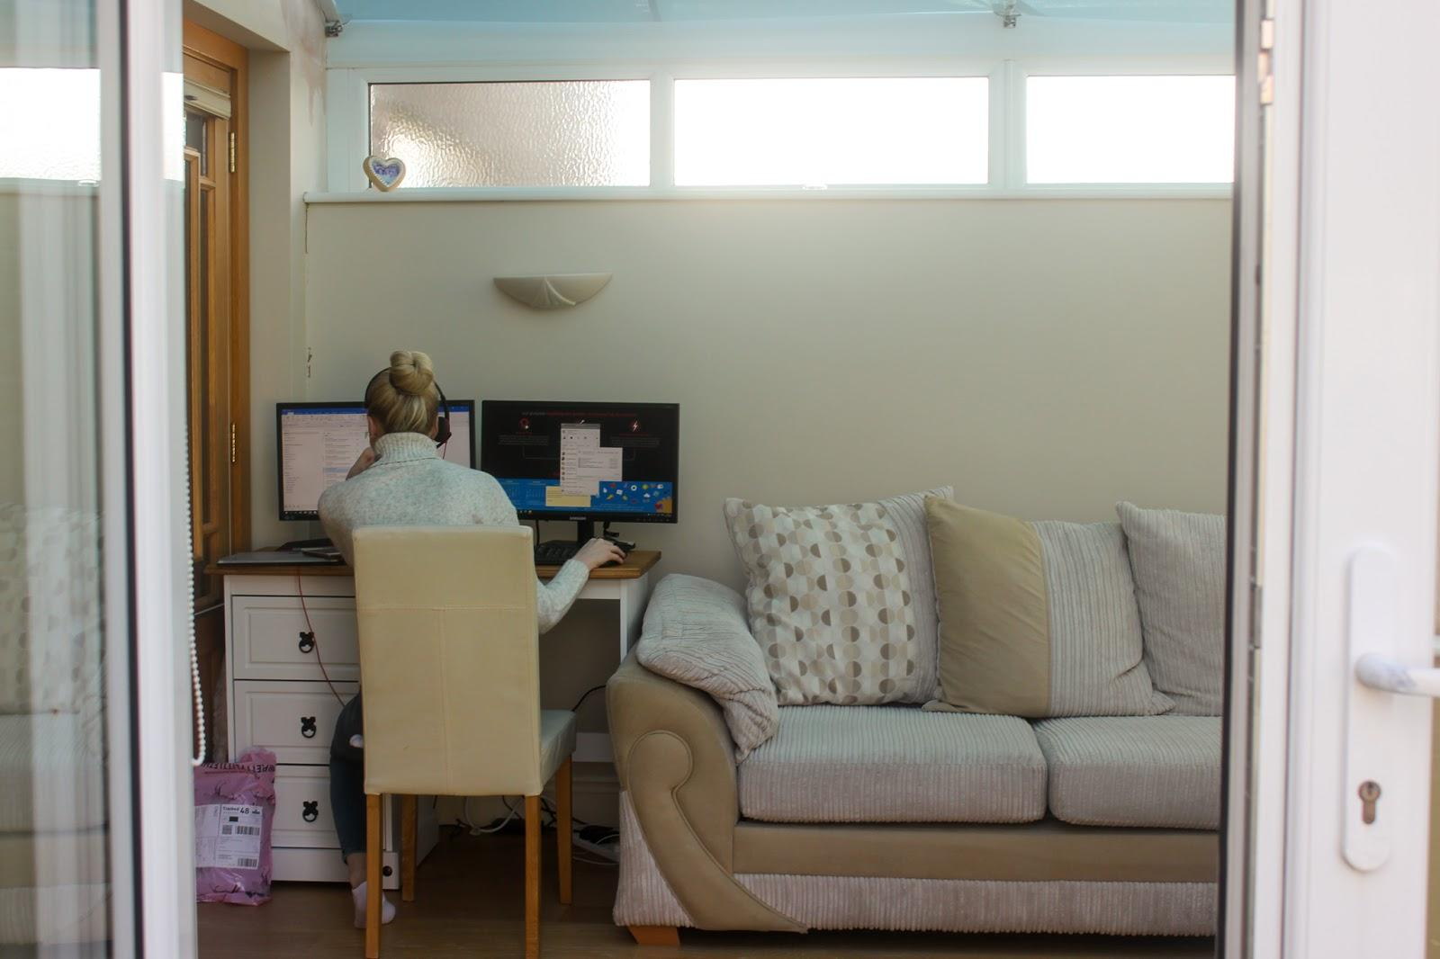

My viewpoint is exemplified in my own personal study project: I am taking a personal perspective of the impact of the coronavirus restrictions, isolation and illness within my own family and home. Therefore, my visual responses are subjected by my relationship to my subjects being my family, and my motives behind this project to give viewers an insight into an impacted family, and to be kept as a record upon reflection in years to come as to how our routines were shifted so substantially because of the pandemic. In my project I am considered an insider looking in, due to my subject being close to me both physically and emotionally, thus potentially creating a more subjective view towards their reality and creating an element of biased photographs. However, with reference to Abigail Solamon-Godeau’s insider/outsider perspective, she implies that my immersive approach can more successfully represent reality due to my own understanding of what is occurring. Additionally, it can be argued that my documentary techniques, capturing my daily experiences of the pandemic on a daily basis is essentially truthful and my camera has acted as a witness throughout this period to how my family, and representing the wider society, were forced to adapt our lives due to the events of the world and the ways life has been turned upside down. As demonstrated in one of my outcomes above, my sister is shown to be adapting to working in her full-time job from the base of our conservatory. My image can be arguably a depict of reality: I captured my sister oblivious to the presence to the camera lens throughout her working day, I have kept my editing process in Adobe Lightroom to a minimum, with the original frame and tones present and thus this is potentially an accurate representation of an example of how my family has been forced to adapt to the pandemic, just as everyone else has globally. However, the authenticity and truthfulness can always be questioned in my creation of my images: I chose to take the outcome in ambient lighting, to ensure the exposure was bright and clarified. Additionally, I have cleared additional objects that were previously in the space within the frame to ensure the image is more aesthetic. Moreover, my relationship to my subject, being my own sister, perhaps allowed me to take the image without her consent which contributed to a more naturalistic outcome being composed; other photographers such as Lange and Nawchety may have to engage with their subjects beforehand, which highlights my previous points on how this may lead to a more posed outcome, where the subject is under pressure due to their awareness of the camera which can distort it’s reality. Overall, I am bearing witness to the reality of the pandemic and the contextual messages being portrayed are a representation of the truth. Nevertheless, my visual outcomes from a personal perspective contained inside my house, capturing my family members and daily occurrences, both the ordinary and extraordinary, always introduces a challenge to objectivity. I subconsciously focus on creating an aesthetically pleasing image by considering the formal elements in my construction, and so the taking of the photograph also defines the sensibilities and narrative of the photo.

Photography can successfully bear witness to reality by capturing the events of the world, as photos act as a method of freezing time of these moments. However, the ways in which these are documented are subjected by the perspective of the photographer: there will always be an opinion behind the lens.

*“The documentary seems to be a mode that finds itself somewhere in-between fact and fiction, or between realism and constructivism* [24](https://americansuburbx.com/2018/07/max-pinckers-interview-speculative-documentary.html.)*.”- Max Pinkers*

**BIBOLOGRAPHY**

1 www.goodreads.com. (n.d.). *A quote from On Photography*. [online] Available at: https://www.goodreads.com/quotes/195221-photographs-are-a-way-of-imprisoning-reality-one-can-t-possess-reality [Accessed 27 Dec. 2020].

2 Halber, J. and Sontag, S. (1979). On Photography. *Leonardo*, 12(4), p.344.

‌3 Wikipedia Contributors (2018). *Truth claim (photography)*. [online] Wikipedia. Available at: <https://en.wikipedia.org/wiki/Truth_claim_(photography)>.

4 visual-arts-cork.com. (n.d.). *Documentary Photography: Characteristics, History*. [online] Available at: http://visual-arts-cork.com/photography/documentary.htm#:~:text=The%20simple%20beginnings%20of%20documentary%20photography%20can%20be [Accessed 27 Dec. 2020].

5 Gem mae. (2016). *Art Movement: Straight Photography (Unit 5 & 30)*. [online] Available at: <https://gemmaephotography97.wordpress.com/2016/01/28/art-movement-straight-photography/>.

6 Wikipedia Contributors (2019). *Documentary photography*. [online] Wikipedia. Available at: <https://en.wikipedia.org/wiki/Documentary_photography>.

7 Sunil Shah (2018). *Max Pinckers Interview: On Speculative Documentary*. [online] AMERICAN SUBURB X. Available at: <https://americansuburbx.com/2018/07/max-pinckers-interview-speculative-documentary.html>.

8 BrainyQuote. (n.d.). *Giles Duley Quotes*. [online] Available at: https://www.brainyquote.com/quotes/giles_duley_559497 [Accessed 27 Dec. 2020].

9 The Art Story. (2016). *Henri Cartier-Bresson*. [online] Available at: <https://www.theartstory.org/artist/cartier-bresson-henri/>.

10 The Editors of Encyclopedia Britannica (2019). Dorothea Lange | Biography, Photographs, & Facts. In: *Encyclopædia Britannica*. [online] Available at: https://www.britannica.com/biography/Dorothea-Lange.

‌11 Wikipedia. (2020). *Great Depression*. [online] Available at: https://en.wikipedia.org/wiki/Great_Depression#:~:text=The%20Great%20Depression%20was%20a%20severe%20worldwide%20economic [Accessed 27 Dec. 2020].

12 Davis, L. (n.d.). *Migrant Mother: Dorothea Lange and the Truth of Photography*. [online] Los Angeles Review of Books. Available at: https://lareviewofbooks.org/article/migrant-mother-dorothea-lange-truth-photography [Accessed 27 Dec. 2020].

13 Wikipedia Contributors (2019). *Dorothea Lange*. [online] Wikipedia. Available at: <https://en.wikipedia.org/wiki/Dorothea_Lange>.

14 Davis, L. (n.d.). *Migrant Mother: Dorothea Lange and the Truth of Photography*. [online] Los Angeles Review of Books. Available at: <https://lareviewofbooks.org/article/migrant-mother-dorothea-lange-truth-photography>.

15 Hull, C. (n.d.). *12 Most Important Quotes from Susan Sontag on Photography*. [online] ExpertPhotography. Available at: https://expertphotography.com/susan-sontag-on-photography-quotes/ [Accessed 6 Jan. 2021].

16 Aperture Buzz. (2018). *James Nachtwey | War Photographer | Life, Inspiration and Witness.* [online] Available at: https://www.aperturebuzz.com/james-nachtwey-war-photographer/.

17 Jamesnachtwey.com. (2019). *James Nachtwey*. [online] Available at: http://jamesnachtwey.com/ [Accessed 28 Oct. 2019].

18 Aperture Buzz. (2018). *James Nachtwey | War Photographer | Life, Inspiration and Witness.* [online] Available at: <https://www.aperturebuzz.com/james-nachtwey-war-photographer/>.

19 Gray, A. (2008). *James Nachtwey quotes on his methods, beauty in his work, and style (plus a video) | Andy Gray at Photosensibility.com*. [online] Andy Gray at Photosensibility.com. Available at: http://www.photosensibility.com/2008/12/22/james-nachtwey/ [Accessed 27 Dec. 2020].

20 PDF Residential. (2020). *ABIGAIL SOLOMON GODEAU INSIDE OUT PDF*. [online] Available at: https://capstoneresidential.info/abigail-solomon-godeau-inside-out-11/ [Accessed 13 Jan. 2021].

21 Halber, J. and Sontag, S. (1979). On Photography. *Leonardo*, 12(4), p.344.

22 Rosler, M. (2006). *In, around, and afterthoughts (on documentary photography) (1981)*. [online] Available at: <http://web.pdx.edu/~vcc/Seminar/Rosler_photo.pdf>.

23 Vittoria Somaschini (2013). *Capturing time: reproduciblity, the real, and photography | CCTP725: Cultural Hybridity: Remix and Dialogic Culture*. [online] Georgetown.edu. Available at: https://blogs.commons.georgetown.edu/cctp-725-fall2013/2013/12/03/capturing-time-reproduciblity-the-real-and-photography/ [Accessed 27 Dec. 2020].

24 Sunil Shah (2018). *Max Pinckers Interview: On Speculative Documentary*. [online] AMERICAN SUBURB X. Available at: <https://americansuburbx.com/2018/07/max-pinckers-interview-speculative-documentary.html>.

‌

‌

‌

‌

‌

‌

‌

‌

‌

‌

‌

‌

‌

‌

‌

‌

‌

‌

‌