Anna Houiellebecq

How and why do photographers use the human body to physically express hidden emotions?

*" I run in my thoughts, in my head.*

*The influx of false thoughts.*

*I am looking for one true thought.*

*Which will let me fall asleep on time.[1]"- Michal Konrad*

The depiction of the human body has been a reality since the origins of photography. The body is used to force the viewer to think critically about contemporary political, cultural, sexual, gender, and socio-economic issues. There is a large amount of work depicting the human body in very different ways. It is used as a tool to express what can’t be said in a photograph. It’s a physical visualisation of unearthed emotions. Although photographers fail to capture people’s voices, many psychologists believe that non-verbal communications reveal much more than words.  The diverse representation of the body has inspired many contemporary artists, including the contemporary photographers Viviane Sassen and Michal Konrad. Both photographers use the human body to represent the process of the mind.  Some photographers explore the possibilities by fragmenting the body in order to express their concerns. The surrealist photographers disturb the viewer in order to provoke a reflection in the Modern World such as Claude Cahun who uses herself portraits looking directly at the viewer with her shaved head, aiming to blur gender indicators. Within my essay I will be discussing how photographers over time have changed their perspective of the female body. They have created a unique angle of what they view the human body to represent. The historical photographers that I will be comparing are Rebecca Horn and Francesca Woodman. These women don’t simply just take images of the body; they distort it in some way to create their twisted realities. Both these women are from challenging backgrounds and faced many complications when expressing their views. I will also be exploring the social and cultural meanings of the female nude within my project, and the major differences between the female and male gaze. I will be discussing how women have transformed photography by becoming the photographer rather than just the subject. In my project, my main aim is to create a visual link between body image and mental processes. I also plan to include conceptual photography into it and discuss how the influence of the imagination links to the process of the mind. The two combined creates this false world that photographers use to influence their work and develop their explorations.

 My initial step is to explore, ‘How and why do the photographers Viviane Sassen and Michal Konrad use the human body to physically express hidden emotions’, is to analyse the life and work of the photographers in question. The first photographer I will be exploring is Viviane Sassen who is a Dutch Photographer, born in 1972. Her work includes both fashion and fine art photography. She is mostly known for her use of geometric shapes, regularly abstractions of bodies. The images of bodies are usually intertwined, inspired by daily physical contact with strangers which she experienced in Africa. As a child Sassen lived in Kenya which now influences much of her work. She often travels to Africa to complete her projects and she allows the local culture and environment to stimulate new ideas. Sassen started studying fashion in Arnhem, Netherlands, however she swiftly choose to focus primarily on photography. Her work comes from an alternative route where she combines personal, editorial and commercial ideas. She embraces an interdisciplinary attitude, which is along the basis of combining two or more academic disciplines into one activity. Sassen believes “You should always be able to judge a photograph on different grounds, on political, social, emotional, but also on personal grounds.”[2]

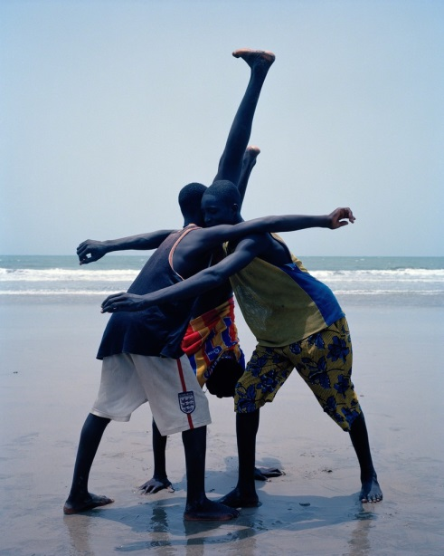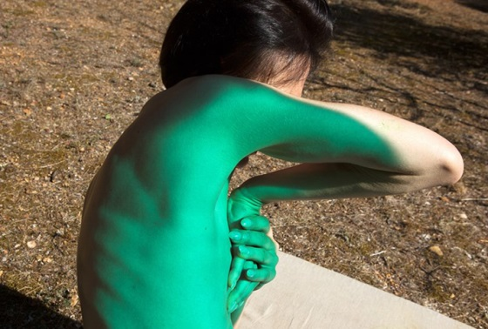After learning about Vivane Sassen, I know that her ultimate stimulant for her ideas and inspirations is her own ‘*personal grounds*’ and experiences. She draws on the memories of three years spent in Kenya as a child. Sassen is using her own personal experiences and emotions to create her ideal format of work. However, Sassen does not solely focus on her own emotions; she also explores the emotions of others. In a series called Parasomnia in 2010, she references a sleep disorder that involves abnormal dreams, nightmares and sleepwalking. Much of Sassen’s work references this dream-like world that she creates using colours and shapes. In a quote from Sassen she says, ‘I try to make images that confuse me, and I hope they confuse you too’[3]. I believe I would base Sassen’s work into the Surrealist category. Her work contains elements of a surreal dreamscape containing ‘Lithe bodies, their faces often casting shadow, pose with mysterious props and objects’. Sassen aims to confuse us as viewers because surrealist photographers disturb the viewer in some way to provoke a reflection on what they are witnessing. In an interview by Dazed and Confused Magazine with Viviane Sassen, she says, ‘I feel that most of my work is about love and loss’, she also includes, ‘fear and longing.[4]’ Sassen is using these common human emotions to integrate into her work. She is fundamentally using the human body as a symbol of these emotions. The reason to why Sassen uses the human body as the subject of these feelings is because the human body is an expressive tool. It is flexible and can provoke a lot of emotions, tensions and contradictions through the use of movement. We as humans use our body every day to portray certain emotions and to provoke certain responses.

In a series of books by Sassen called Roxane I and Roxane II, she investigates what it means to be female. Within this series she focuses on a woman called Roxane Danset. The books contain images of Danset posing as a ‘goddess, the wise mother, the sexual Venus, the innocent and playful child and more’[5].  When questioned about the series, Sassen explains how it is useful being a woman when using a woman as her subject.  She says, ‘it helps because we are both preoccupied with the female gaze’.[6] Sassen wants to explore the psychology of collaboration and inclusivity when creating images of women instead of wanting to display them in a sexual manner. When she says, ‘we are both preoccupied with the female gaze’[7], she is exploring the female body from a women's point of view, rather than a males. Sassen also says she aims to ‘cherish the female body and mind with all its imperfections’[8]. This again shows how men and women view female bodies in a different manner. Females ‘cherish the female body and mind’[9] because they see and think about things in a varied way compared to men. Viviane Sassen is included in the generation of female photographers who have challenged the normal perspective and have created their unique idealistic interpretation of the human body. She is also one of the many female photographers who have helped with the progression of women in this field. Roxane was the subject chosen by Sassen for this shoot because she has the power to display the actions and manners that Sassen wants to create. Her images are provocative because she aims to promote a reaction within the viewer’s mind that will lead to a new way of thinking. She is using the female form as a tool to display female emotions because it is easier to relate with someone of the same gender as you. Throughout history the female body has been displayed as a sexual object, disregarding its purity. In her series Sassen is attempting to promote this purity again by looking into the spiritual and hidden aspects of women rather than just their physical, sexual form.

The female and male gaze is very significant in the subject of art. The gaze is a term used to describe how viewers engage in visual media. It originated in film theory in 1970’s, and refers to how we look at visual representations. The male gaze invokes the sexual ideas of the gaze and it references a sexualised way of looking that empowers men and objectifies women. Within the male gaze, women are often visually positioned as an object of male desire. The subject’s feelings and thoughts are less important than her influence to male desire. In a book called ‘the Female Nude’ by Lynda Nead, she argues that one of the principal goals of the female nude has been the regulation of the female sexual body, “the principle goals of the female nude have been the containment and regulation of the female sexual body.”[10] The book contains a quote from Aristotle saying, “The chief forms of beauty are order and symmetry and definiteness.”[11] In this quote Aristotle is referencing the creation of the ideal body image. Society’s view on the perfect body image has changed throughout history, and the main concept that has led to certain developments and progressions is the male gaze. Nead references the male gaze within her book when she talks about the influence it has. She writes, “the fantasy of the controlling power of the male gaze.”[12] Depending on what the male desired, the ideal body image changed. Peter Paul Rubens, a 17th century Flemish Baroque painter, was famous for his depictions of plump, sensual women. Up until the 20th century, curvy, voluptuous women were considered ideally beautiful in the U.S. and Europe. Women are insistently presented as sexual objects, and because of this it is difficult for women to progress through this form of media. By creating the series Roxane, Sassen is presenting the female form in many different ways, not just a sexualised object. She is destroying the normal expectations and portraying the female nude in the way it should be represented. 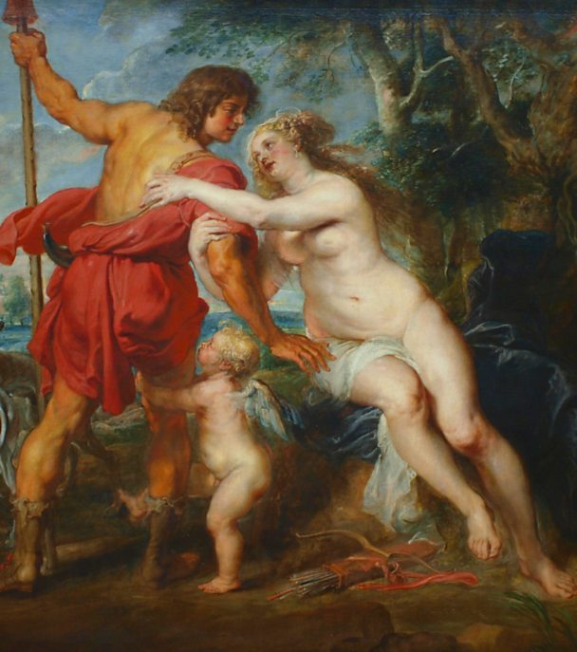

The next photographer I will be exploring is the work by Michal Konrad who is a polish photographer born in 1983 in Wodzistaw Slaski. From an early age Konrad was fascinated with photography and visual art. In the Dodho Magazine, Michal talks about when he first began becoming interested in this form of art, ‘I started photographing analogue camera in my youth’. [13]He has been studying and evolving his style of work for several years; however since 2010 his work has become more conscious and planned. Konrad has always been interested in conceptual photography and believes it is important to have a deeper thought process when creating a series of works. Konrad says ‘photography becomes a way of their expression’. [14]He is explaining how he uses his thoughts and emotions to provoke his images. Konrad also writes, ‘I always liked to play with memory’[15]. He uses his own memories to create his series. An example of one of his series where he uses this concept is a series called Transition which he did in the summer and autumn of 2016. Within this project he takes the images using a 20 second shutter release. According to Michal Konrad, the entire cycle of the project took three months.  The quote that Konrad uses to explain the series is ‘You can go to the other side, or change the state of consciousness. You can find the secret window through which we will enter a new dimension’[16]. Konrad is explaining what the meaning of transition is in a descriptive way. He is describing it as a process of climbing through a ‘secret window’. Konrad is stating it can be a psychological process as well as a physical process. He says you can either ‘go to the other side’, which would mean a physical movement, or ‘change the state of consciousness’, which would be a process of the mind. This is what Konrad is demonstrating within the project. He is capturing the process of a physical movement to symbolise a psychological transition. This series, Transition is an example of how Michal Konrad uses the human body to physically express hidden emotions. Konrad chooses to use the human body, himself, as the subject for his work because his projects are about emotions that he can relate too since he has experienced them. He has given himself the task of physically displaying these emotions because he knows how they can effect us in certain ways.Instead of using a man made object or the natural landscape Konrad choose the 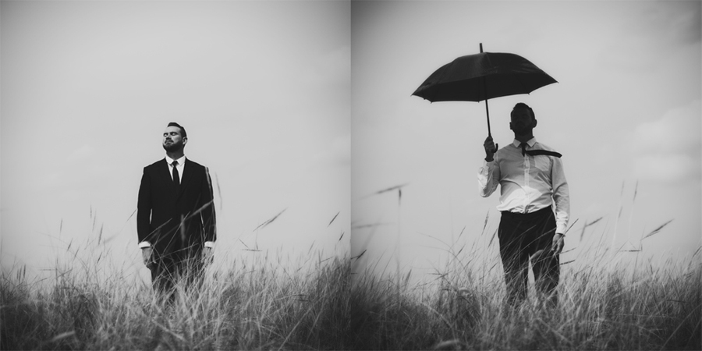human body to express hidden emotions because the human body is the most expressive tool there is.

Another series that Konrad has created is called Insomnia. The series Insomnia primarily focuses on psychology and the process of a person’s mind. He is again using the body to express hidden emotions. The project shows how a person perceives the environment in the modern world and how the environment affects him. The busy world that we live in can often provoke unsettling emotions such as pain and confusion. On the website Scopio, Konrad explains that the title Insomnia is meant to ‘show the anxiety in the modern world, caused by lies’[17]. Insomnia is a sleeping disorder that is characterised by difficulty falling asleep. I believe that Konrad used this title for this series because he wants the title to express what the series is about. He is showing that the ‘anxiety’ caused by ‘lies’ could cause the disorder Insomnia. Similarly to Viviane Sassen, Konrad can be based under the category of Surrealist Photographers because his images are balancing on the border of dream and imagination. Konrad himself has experienced the disorder insomnia and he is using his experiences to influence his work. The series Insomnia is yet again another example of Konrad using the human body to express hidden emotions, in this case confusion and anxiety.

Michal Konrad is fundamentally using himself and other men to photograph. Vivian Sassen also uses other females to express her points of view. I believe photographers who aim to discover a deeper and more thought provoking set of images mainly stick to using a subject who is of the same gender as them. They do this because they can relate to the emotions and psychological process of someone who is of the same sex more than someone who is of the opposite sex. This again relates to the female and male gaze which Lynda Nead talks about within her book The Female Nude. She references the fantasies that the male gaze contains, “exposes the fantasy”.[18]Since females are not preoccupied with the fantasies that the male gaze contains it makes it easier to work with them when using creating images containing the female nude.

As well as the contemporary photographers Viviane Sassen and Michal Konrad, I am also going to be discussing the historical photographers Rebecca Horn and Francesca Woodman. Both these women went through some process of hardship during their lives which they used to inspire their work. They also both defied the norm to create their ideal reality. They expressed their unique view using their individual style and set of images.

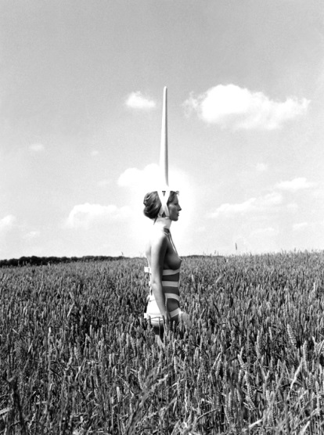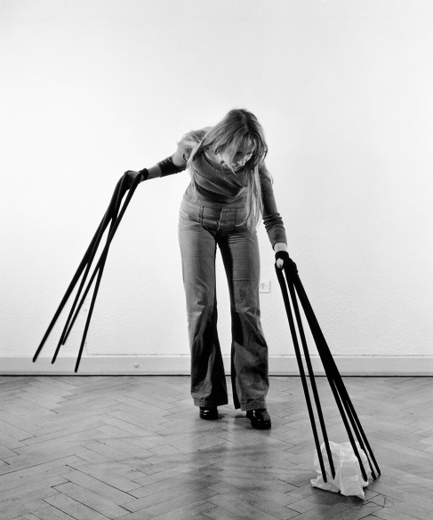Rebecca Horn was born in March 1944 in Michelstadt, Hesse. She is a German visual artist who creates these unique sculptures and installations to express suffering and torment. She is best known for her film directing and unique body modifications. She also practices body art using different Medias such as performance art, installation art, sculpture and film. She enjoys writing poems which she often uses to influence her work. It was in 1968 when Horn produced her first body sculpture where she attached objects and instruments to the human body. She used the relationship between a person and their environment as the theme. One of Rebecca Horn’s most well-known performance pieces is called Einhirn, which translates into Unicorn. The subject of this piece is a women who was described by Horn as very bourgeois. Within the film the subject is seen walking through a field and forest on a summer morning wearing nothing but a white horn from the top of her head. Her work can be interpreted in many ways, however from researching Horn I know that just like the other photographers I have talked about so far, she also uses her past memories and personal  emotions to access these unique ideas and concepts. Rebecca Horn had a difficult life, similar to many women during her time. Her parents sent her to boarding school to later study economics, however at nineteen Horn rebelled against her parents to study art. In 1963 she attended the Hamburg Academy of Fine Arts. Exactly a year after joining, Horn had to pull out after contracting severe lung poisoning. This is how Horn describes her experience, ‘I was working with glass fibre, without a mask, because nobody said it was dangerous, I got very sick. For a year I was in a sanatorium’. [19]Even after working so hard to achieve the career that she dreamed to reach, Horn’s hardship was not over. She carries on saying, ‘My parents died. I was totally isolated’. [20]Horn experienced severe isolation during her life, and felt like her life was over before it had begun. She was too ill to go back to school when leaving the hospital, and therefore she turned to creating sculptures and strange extensions using wood and cloth as a type of therapy. Horn is yet again another example of an artist who uses her emotions and anger to promote her work. Instead of simply taking images of the human body as a symbolic reference of her emotions, Horn goes further by creating sculptures as extensions of the body. She uses these extensions, as well as the human form to transform her ideas and hidden feelings. Horn creates these sculptures as extensions of herself because she believes that the human body is not powerful enough to symbolize the emotions she wants it to represent. She sees hidden feelings as extensions of herself rather then something that’s part of her.

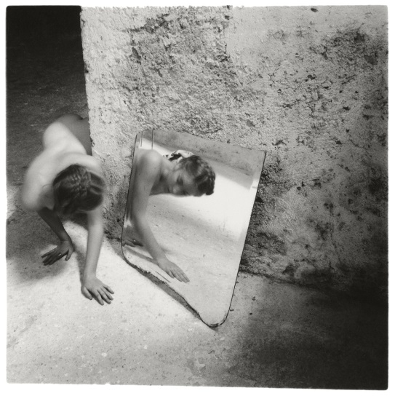Francesca Woodman is the other historical photographer that I will be referencing in my essay. She is an American Photographer who was born in April 1958. She is best known for her black and white pictures featuring either herself or other females. Many of Woodman’s images contain the subject naked or clothed, blurred or merging with their surroundings. Her work only began gaining attention after her death at the age of 22 in 1981. Life as a working artist was extremely hard, especially as a female. According to Francesca’s father, she found it sufficiently difficult trying to become an established artist. He says it wasn’t Francesca’s work that troubled her; it was the art world, competitive and precarious, that she found scary. In the late 1980’s Woodman became depressed due to the failure of her work to attract attention. She survived a suicide attempt in the autumn of 1980. However, on the 19th January 1981, Woodman died by suicide after jumping out of a loft window. The images that Woodman creates are very haunting and mysterious because she uses her emotions of depression, as an influence. They contain this eery atmosphere because of her use of environment, the bleakness, and also because of the poses that the subject is doing. Woodman was clearly struggling with her life which I can feel when dissecting her images. The black and white really emphasises the haunting and death like atmosphere that Woodman creates. Her images are relatively similar to Rebecca Horn’s because they both use themselves as the main subject. The atmosphere that they create coincides with their experiences with their life.

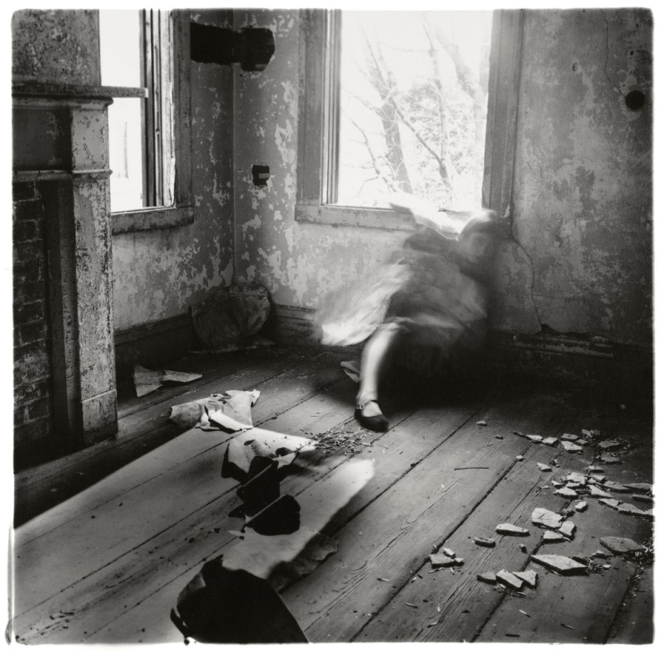The image on the right is taken by Francesca Woodman in 1976 on Rhode Island, five years before the photographer’s suicide in 1981. Woodman had created a collection of around 800 images throughout her short life. She used herself as the main subject for most of them, and strips away her identity using movement to create a blurred effect. Most of her images including this one are in black and white because she used a black and white film camera to produce most of her work. The atmosphere and bleakness created coincides with the dark theme. The black and white filter helps produce this ghostly environment that produces ideas of death and mourning. The interior of the place where the picture was taken is very withered and old, with broken tiles and glass spread across the floor. The walls are tainted with mould and the wallpaper is slowly collapsing. Although the dilapidated interior is not what Woodman is aiming to capture, the environment in which the image is taken helps to produce this bleakness. The interior helps reflect her interior emotion, “Woodman’s work often captured her in isolation, in dilapidated interiors, where her body is partially absent or obscured. She is both present and absent – her identity removed by the obscuring of her features.”[21] The main subject of the image is Woodman herself contained in this prison like room, locked up. The room is dark and dull but there are two windows in the image allowing bright light to sweep through. Woodman is seen leaning against one of the walls of the room facing towards the camera, face turned away from the light. She has concealed her identity, ripping away her life from the image. The image creates emotions of death, loneliness and the feeling of being trapped. After learning a lot about Woodman’s short life I know that she uses her own emotions and experiences to come up with her themes. She dealt a lot with depression throughout her 22years, and she uses this pain to stimulate her ideas. Woodman’s images have a modernist, surrealist and gothic atmosphere to them. Within her work, she is constantly trying to escape or hide which coincides with her experiences in life. There is a continuous performance in which she plays with the notion of disguising, transforming and defacing her own body. Some people may believe that Woodman is foreseeing her own suicide within her images because she is constantly destroying herself in the frame. When critically analysing this image by Francesca Woodman I have managed to achieve a greater understanding to why she uses herself as the subject of her work. Similarly to the photographer Michal Konrad, Woodman is able to relate to her themes of suffering and loneliness and therefore can portray these emotions in a realistic manner. I know that woodman suffered with depression and because of this her style of work evokes a strong sense of pain. It’s because of the experiences that she had that promoted her work. She is using her own body to symbolize her own emotions, and that’s what makes her work so powerful and real.

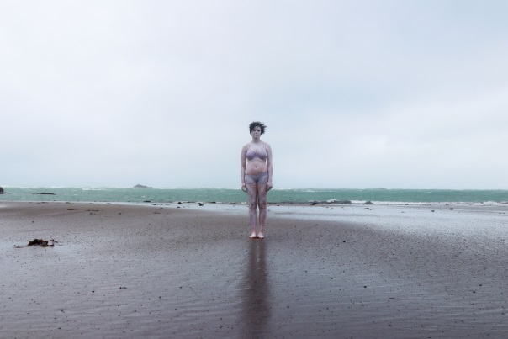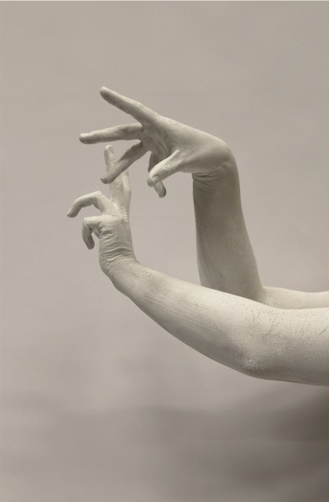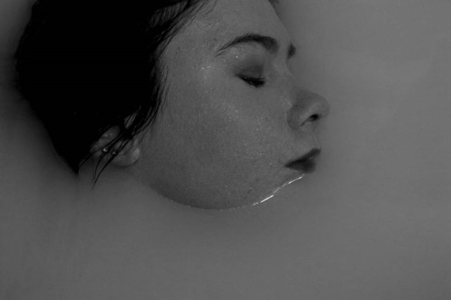For my personal study I also explored the human body and the different ways it can be used to express hidden emotions. Similarly to the photographers I explored, I used subjects of the same gender to represent my work. After doing shoots with subjects of both genders, I realised that I was more comfortable and able to express what I wanted to achieve more with a female because we shared the same viewpoints. As well as using other females, I also used myself, which is what both my historical photographers did and my contemporary photographer Michal Konrad. It was a difficult task photographing myself because I had to hold the camera above me for a long period of time. I also had to keep repositioning myself if I didn’t like the framing. However, it was a new experience and I was also able to clearly portray and capture what I wanted without having to explain it to the subject. Throughout my project I fragmented different parts of the human body and solely focused on them to represent certain emotions. In one of my shoots I choose to focus on the hands. The hands are one of the most expressive parts of the human body because they can symbolize a variation of emotions just by a simple movement. It was the photographer Viviane Sassen who influenced my idea for this shoot because she uses twisted formations of human body’s to represent her ideas. Another part of my personal study that was inspired by Michal Korad and Francesca Woodman was the use of the environment in my work. Both of these photographers placed their subject amongst an environment that also symbolized their emotions. In one of my shoots I used the subject to represent conformity and the feeling of being invisible and lost within society. I choose to do the shoot on an empty beach because the vastness of nothing ties in with the emotion of being invisible and lost.

Both the contemporary and historical photographers that I have talked about have used the human body in altered ways to evoke certain hidden emotions. I can conclude that the reason why they use the human form to symbolize these feelings is because of how powerful and expressive the human body can be. Although they may be using the body as a tool in different ways, they are all doing it for the same reason, which is trying to promote a strong message through their work. The human body is a flexible tool and can be used to represent many different things including emotions. It’s the expressive qualities that it has that make it such a powerful tool. I also believe that they use the human form because the viewers are able to relate to the characteristics that it holds and the expressions that it possesses. Both of the photographers use movement alot to express what is unseen. Sassen uses movement in a physical way, by capturing her subjects in a moving pose, whereas Konrad uses movement as a mental state. Within Sassen’s images she includes a lot of bright colours, shapes and shadows to help interpret what she wants to achieve. The use of the colours could be another way of her expressing the emotions. Most of Konrad’s images are dark and mysterious which complements his ideas well because the emotions he is expressing are also dark and mysterious. As well as looking at the contemporary photographers in question, I wanted to include historical photographers to show how the way we interpret emotion into images has changed. Both of the historical photographers I looked at, Rebecca Horn and Francesca Woodman, focused on their personal feelings, and used these to create their twisted images. Similarly to my contemporary photographers, Horn and Woodman both use movement a lot to express their hidden emotions.

*“The Human body is the best picture of the Human soul” -Ludwig Wittgenstein[22]*

Bibliography

Scopio Network. (2018). INSOMNIA. [online] Available at: http://www.scopionetwork.com/node/1000#1 [Accessed 12 Jan. 2018].

2 Dazed. (2018). Viviane Sassen’s new photobook on friendship and femininity. [online] Available at: http://www.dazeddigital.com/photography/article/35767/1/viviane-sassen-photo-book-roxane-ii-femininity [Accessed 15 Mar. 2018].

3 Dazed. (2018). Viviane Sassen’s new photobook on friendship and femininity. [online] Available at: http://www.dazeddigital.com/photography/article/35767/1/viviane-sassen-photo-book-roxane-ii-femininity [Accessed 15 Mar. 2018].

4 Dazed. (2018). Viviane Sassen’s new photobook on friendship and femininity. [online] Available at: http://www.dazeddigital.com/photography/article/35767/1/viviane-sassen-photo-book-roxane-ii-femininity [Accessed 15 Mar. 2018].

5 Dazed. (2018). Viviane Sassen’s new photobook on friendship and femininity. [online] Available at: http://www.dazeddigital.com/photography/article/35767/1/viviane-sassen-photo-book-roxane-ii-femininity [Accessed 15 Mar. 2018].

6 Dazed. (2018). Viviane Sassen’s new photobook on friendship and femininity. [online] Available at: http://www.dazeddigital.com/photography/article/35767/1/viviane-sassen-photo-book-roxane-ii-femininity [Accessed 15 Mar. 2018].

7 Dazed. (2018). Viviane Sassen’s new photobook on friendship and femininity. [online] Available at: http://www.dazeddigital.com/photography/article/35767/1/viviane-sassen-photo-book-roxane-ii-femininity [Accessed 15 Mar. 2018].

8 Dazed. (2018). Viviane Sassen’s new photobook on friendship and femininity. [online] Available at: http://www.dazeddigital.com/photography/article/35767/1/viviane-sassen-photo-book-roxane-ii-femininity [Accessed 15 Mar. 2018].

9 Dazed. (2018). Viviane Sassen’s new photobook on friendship and femininity. [online] Available at: http://www.dazeddigital.com/photography/article/35767/1/viviane-sassen-photo-book-roxane-ii-femininity [Accessed 15 Mar. 2018].

10 Nead, L. (2002). The Female Nude: Art, Obscenity and Sexuality. Taylor & Francis, p.6

11Nead, L. (2002). The Female Nude: Art, Obscenity and Sexuality. Taylor & Francis, p.7.

12Nead, L. (2002). The Female Nude: Art, Obscenity and Sexuality. Taylor & Francis, p.40

13Dodho Magazine. (2018). Transition by Michal Konrad | Dodho Magazine. [online] Available at: https://www.dodho.com/transition-by-michal-konrad/ [Accessed 5 Feb. 2018].

14Dodho Magazine. (2018). Transition by Michal Konrad | Dodho Magazine. [online] Available at: https://www.dodho.com/transition-by-michal-konrad/ [Accessed 5 Feb. 2018].

15Dodho Magazine. (2018). Transition by Michal Konrad | Dodho Magazine. [online] Available at: https://www.dodho.com/transition-by-michal-konrad/ [Accessed 5 Feb. 2018].

16 Dodho Magazine. (2018). Transition by Michal Konrad | Dodho Magazine. [online] Available at: https://www.dodho.com/transition-by-michal-konrad/ [Accessed 5 Feb. 2018].

17Scopio Network. (2018). INSOMNIA. [online] Available at: http://www.scopionetwork.com/node/1000#1 [Accessed 12 Jan. 2018].

18 Nead, L. (2002). The Female Nude: Art, Obscenity and Sexuality. Taylor & Francis, p.23

19 (2018). Rebecca Horn born 1944 | Tate. [online] Available at: http://www.tate.org.uk/art/artists/rebecca-horn-2269 [Accessed 14 Mar. 2018].

20Tate. (2018). Rebecca Horn born 1944 | Tate. [online] Available at: http://www.tate.org.uk/art/artists/rebecca-horn-2269 [Accessed 14 Mar. 2018].

21Tate. (2018). The Body | Tate. [online] Available at: http://www.tate.org.uk/artist-rooms/collection/themes/body [Accessed 14 Mar. 2018].

22 Fraser, G. (2018). Investigating Wittgenstein, part 5: Other selves | Giles Fraser. [online] the Guardian. Available at: https://www.theguardian.com/commentisfree/belief/2010/feb/22/wittgenstein-philosophical-investigations [Accessed 14 Mar. 2018].

1. Scopio Network. (2018). INSOMNIA. [online] Available at: http://www.scopionetwork.com/node/1000#1 [Accessed 12 Jan. 2018].
2. Dazed. (2018). Viviane Sassen’s new photobook on friendship and femininity. [online] Available at: http://www.dazeddigital.com/photography/article/35767/1/viviane-sassen-photo-book-roxane-ii-femininity [Accessed 15 Mar. 2018].
3. Dazed. (2018). Viviane Sassen’s new photobook on friendship and femininity. [online] Available at: http://www.dazeddigital.com/photography/article/35767/1/viviane-sassen-photo-book-roxane-ii-femininity [Accessed 15 Mar. 2018].
4. Dazed. (2018). Viviane Sassen’s new photobook on friendship and femininity. [online] Available at: http://www.dazeddigital.com/photography/article/35767/1/viviane-sassen-photo-book-roxane-ii-femininity [Accessed 15 Mar. 2018].
5. Dazed. (2018). Viviane Sassen’s new photobook on friendship and femininity. [online] Available at: http://www.dazeddigital.com/photography/article/35767/1/viviane-sassen-photo-book-roxane-ii-femininity [Accessed 15 Mar. 2018].
6. Dazed. (2018). Viviane Sassen’s new photobook on friendship and femininity. [online] Available at: http://www.dazeddigital.com/photography/article/35767/1/viviane-sassen-photo-book-roxane-ii-femininity [Accessed 15 Mar. 2018].
7. Dazed. (2018). Viviane Sassen’s new photobook on friendship and femininity. [online] Available at: http://www.dazeddigital.com/photography/article/35767/1/viviane-sassen-photo-book-roxane-ii-femininity [Accessed 15 Mar. 2018].
8. Dazed. (2018). Viviane Sassen’s new photobook on friendship and femininity. [online] Available at: http://www.dazeddigital.com/photography/article/35767/1/viviane-sassen-photo-book-roxane-ii-femininity [Accessed 15 Mar. 2018].
9. Dazed. (2018). Viviane Sassen’s new photobook on friendship and femininity. [online] Available at: http://www.dazeddigital.com/photography/article/35767/1/viviane-sassen-photo-book-roxane-ii-femininity [Accessed 15 Mar. 2018].
10. Nead, L. (2002). The Female Nude: Art, Obscenity and Sexuality. Taylor & Francis, p.6
11. Nead, L. (2002). The Female Nude: Art, Obscenity and Sexuality. Taylor & Francis, p.7.
12. Nead, L. (2002). The Female Nude: Art, Obscenity and Sexuality. Taylor & Francis, p.40
13. Dodho Magazine. (2018). Transition by Michal Konrad | Dodho Magazine. [online] Available at: https://www.dodho.com/transition-by-michal-konrad/ [Accessed 5 Feb. 2018].
14. Dodho Magazine. (2018). Transition by Michal Konrad | Dodho Magazine. [online] Available at: https://www.dodho.com/transition-by-michal-konrad/ [Accessed 5 Feb. 2018].
15. Dodho Magazine. (2018). Transition by Michal Konrad | Dodho Magazine. [online] Available at: https://www.dodho.com/transition-by-michal-konrad/ [Accessed 5 Feb. 2018].
16. Dodho Magazine. (2018). Transition by Michal Konrad | Dodho Magazine. [online] Available at: https://www.dodho.com/transition-by-michal-konrad/ [Accessed 5 Feb. 2018].
17. Scopio Network. (2018). INSOMNIA. [online] Available at: http://www.scopionetwork.com/node/1000#1 [Accessed 12 Jan. 2018].
18. Nead, L. (2002). The Female Nude: Art, Obscenity and Sexuality. Taylor & Francis, p.23
19. (2018). Rebecca Horn born 1944 | Tate. [online] Available at: http://www.tate.org.uk/art/artists/rebecca-horn-2269 [Accessed 14 Mar. 2018].
20. Tate. (2018). Rebecca Horn born 1944 | Tate. [online] Available at: http://www.tate.org.uk/art/artists/rebecca-horn-2269 [Accessed 14 Mar. 2018].
21. Tate. (2018). The Body | Tate. [online] Available at: http://www.tate.org.uk/artist-rooms/collection/themes/body [Accessed 14 Mar. 2018].
22. Fraser, G. (2018). Investigating Wittgenstein, part 5: Other selves | Giles Fraser. [online] the Guardian. Available at: https://www.theguardian.com/commentisfree/belief/2010/feb/22/wittgenstein-philosophical-investigations [Accessed 14 Mar. 2018].