**HOMEWORK & DEADLINES:**

Any student who fails to complete specific tasks or homework on set deadlines will be given a day’s grace, and if still unfinished, will be put in **Supervised Study** that same day after school between 3:30-5:00.

Remember also, that is the policy of Hautlieu School that each students’ should spend an average of up to 5 hours of homework per subject per week, and the homework set in this module reflects that commitment.

**ASSESSMENT:**

This unit is part of your first Coursework module and will be assessed using the following assessment criteria.   
Each assessment objective is awarded between 0-18 marks out of a total of 72 marks.   
Current grade boundaries are: A*= 66/72 A=59/72 B=48/72 C =38/72 D=28/72 E=17/72

**Assessment Objectives A-Level Photography: (Edexcel)**

**AO1** – **Develop** ideas through sustained and focused investigations informed by contextual and other sources, demonstrating analytical and critical understanding.

**AO2** – **Explore** and select appropriate resources, media, materials, techniques and processes, reviewing and refining their ideas as work develops.

**AO3** – **Record** ideas, observations and insights relevant to intentions, reflecting critically on work and progress.

**AO4** – **Present** a personal and meaningful response that realises intentions and, where appropriate, makes connections between visual and other elements.

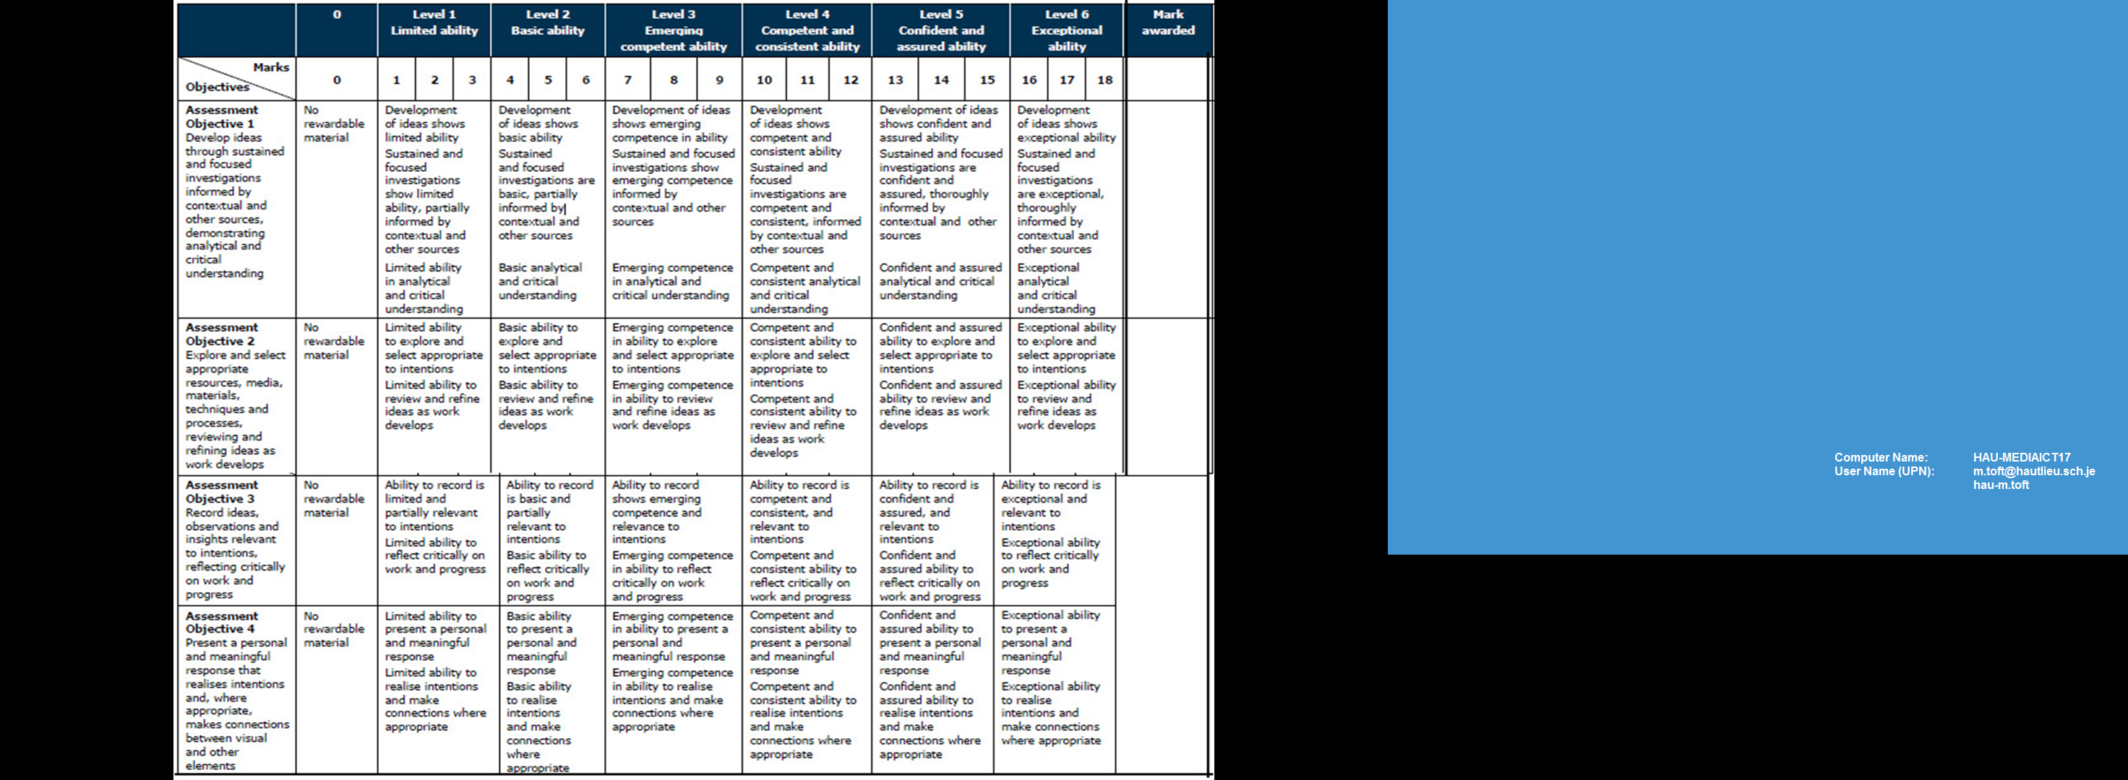

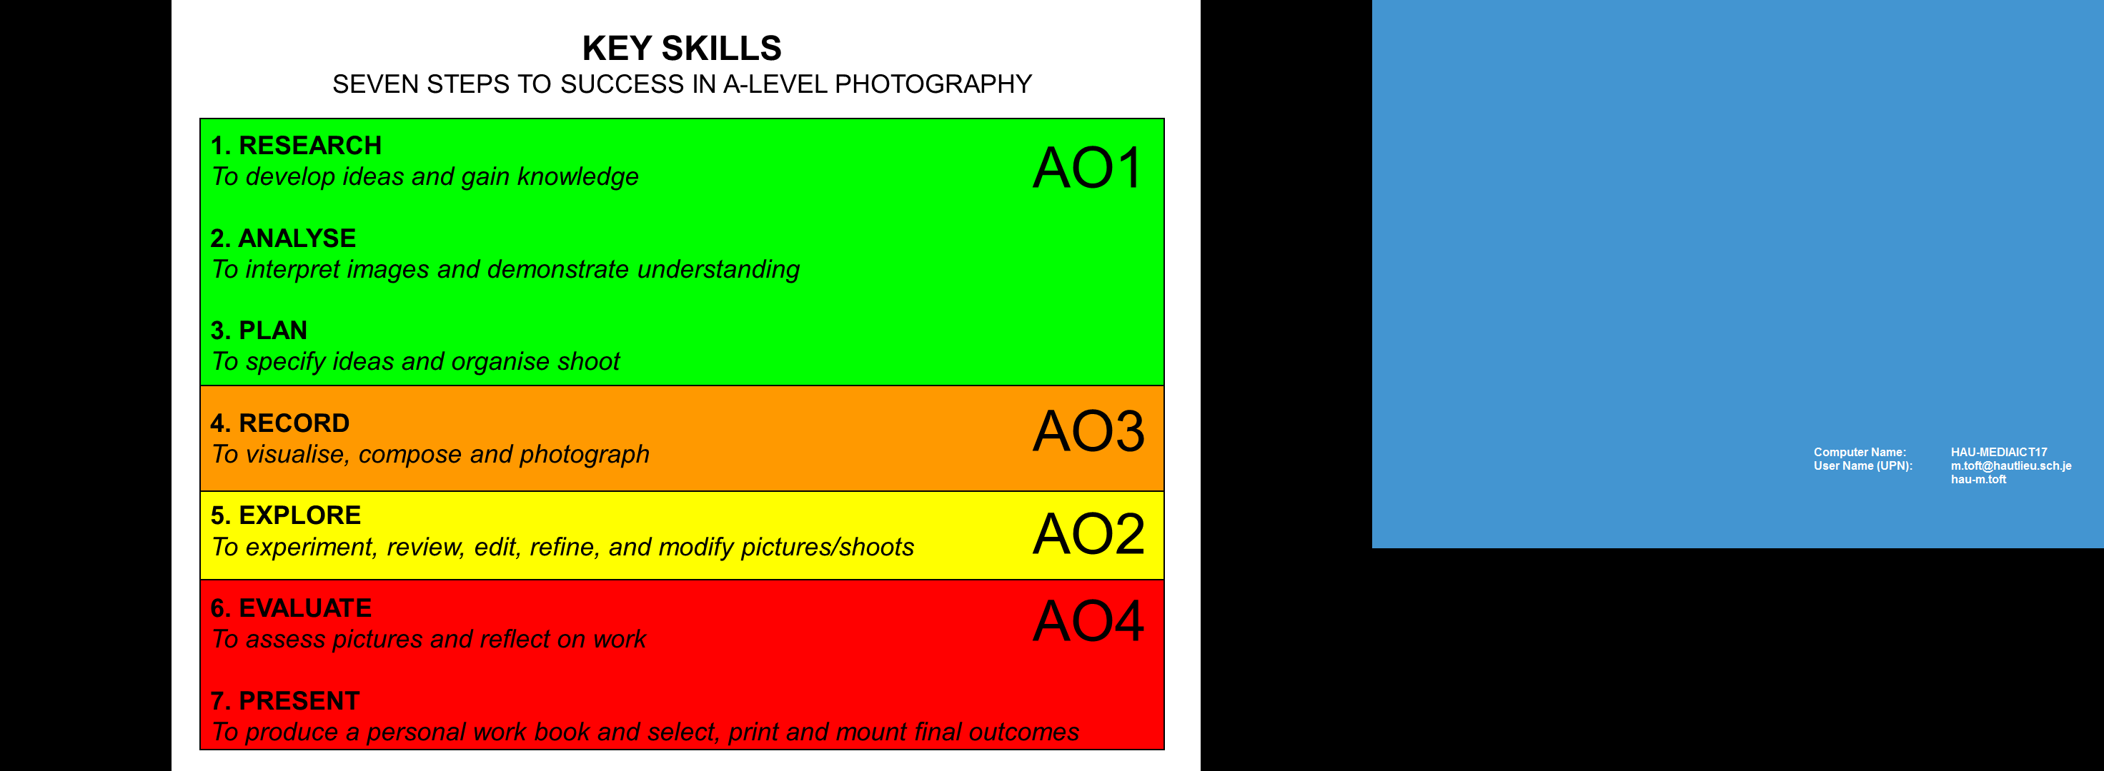

|  |  |  |
| --- | --- | --- |
| ***TRACKING SHEET: AUTUMN TERM*  DEADLINE Wed 22 Nov** | | |
| ***Week 1, 2, 3 & 4 : 5th - 30th Sept* Explore different approaches to family photography**Sections to complete | **Blog posts to improve/ Actions to take** | **Assessment Objectives Self-evaluate Award marks** |

|  |  |  |
| --- | --- | --- |
| PRACTICE > PHOTO-ASSIGNMENTS   1. Documentary: make one environmental portrait using a family member. **Complete by Fri 15 Sept** 2. Tableaux: construct a childhood memory in a photograph. **Complete by Mon 25 Sept** 3. Archive: produce a montage that must include an archival image from your family/ personal photo- album. **Complete by Mon 2 Oct**   ARTIST REFERENCES:  RESEARCH > ANALYSIS: As starting points for your tasks, choose to look at a comparative study of the pairing of artists references above in each area of Documentary, Tableaux and Archive.  Write a thoughtful analysis of each artists and consider how their work is referencing the theme of family - discuss the subject-matter, content, concept, context, construction, composition, camera, then compare, contrast and critique. Ask yourself: What? Why? How?   1. Produce a mood board with a selection of images. 2. Provide analysis of their work and explain why you have chosen them and how it relates to your idea and the theme of FAMILY 3. Select at least 2 key images and analyse in depth, FORM (describe what you see, composition, use of light etc), MEANING (interpretation, subject-matter, what is the photographer trying to communicate), JUDGEMENT (evaluation, how good is it?), CONTEXT (history and theory of art/ photography/ visual culture, link to other’s work/ideas/concept) 4. Incorporate quotes and comments from artist themselves or others (art critics, art historians, curators, writers, journalists etc) using a variety of sources such as Youtube, online articles, reviews, text, books etc. 5. Make sure you reference sources and embed links to the above sources in your blog post   Remember to MAKE YOUR BLOG POST VISUAL and include relevant links, podcasts, videos where possible.  PLANNING > RECORDING: Plan at least 1 shoot as a response to the each photo-assignment above. Show evidence of planning using mind-maps, mood-boards and write a specification with details of how, why, when, where, whom? Be organised and complete one shoot per photo-assignment per week.  DEVELOPING > EXPERIMENTING: Edit shoots and show experimentation with different adjustments/ techniques/ processes in Lightroom/ Photoshop appropriate to intentions. Reflect an evaluate each shoot afterwards with thoughts on how to refine and modify your ideas i.e. experiment with images in Lightroom/Photoshop, re-visit idea, produce a new shoot, what are you going to do differently next time? How are you going to develop your ideas?  EXTENSION: Explore your own family/ personal archives such as photo-albums, home movies, letters, boxes and make a blog post with a selection of material that will inform and develop your Personal Investigation. For example. you can focus on the life on one parent, grand-parent, family relative, or your own childhood and upbringing.  Either scan or re-photograph archival material so that it is digitised and ready for us eon the blog and further experimentation.  Plan at least one photo-shoot and make a set of images that respond to your archival research above and/ or Personal Investigation. |  |  |
| ***Week 5-6: 2nd – 15th Oct* Personal Investigation: Reflection, Research & Analysis**Sections to complete |  |  |
| **Review & Reflection:** 1. Produce a blog post that reflects on your work you have produced so far, including workshops by Tanja and Jonny. Describe which themes, artists, approaches, skills and photographic processes inspired you the most and why. Provide an overview of what you learned and include examples of previous work to illustrate your thinking.  **Research & Analysis** 2. Gather as many visual inspirations as possible that may help you to develop your response to your chosen theme. Make a mood-board and a mind-map and produce at least 4-5 blog posts that illustrate your thinking and understanding. Use pictures and annotation and make a photographic response to initial research!  3. Artists references: Select at least two new photographers and write a thoughtful analysis of each artist and consider how their work is referencing your chosen theme(s) and ideas. Discuss the subject-matter, content, concept, context, construction, composition, camera, then compare, contrast and critique. Ask yourself: What? Why? How?   * Produce a mood board with a selection of images. * Provide analysis of their work and explain why you have chosen them and how it relates to your idea and the theme of FAMILY * Select at least 2 key images and analyse in depth, FORM (describe what you see, composition, use of light etc), MEANING (interpretation, subject-matter, what is the photographer trying to communicate), JUDGEMENT (evaluation, how good is it?), CONTEXT (history and theory of art/ photography/ visual culture,link to other’s work/ideas/concept) * Incorporate quotes and comments from artist themselves or others (art critics, art historians, curators, writers, journalists etc) using a variety of sources such as Youtube, online articles, reviews, text, books etc. * Reference sources and embed links to the above sources in your blog post * Make a photographic response to your research into the work of others. |  |  |
| ***Week 7-8 & 9: 16th Oct – 12th Nov* Personal Investigation: Planning, Recording, Developing & Experimenting**Sections to complete |  |  |
| **Planning & Recording** 4. Write a Specification: Finding your voice and unique way to tell a story. Write a specification with 2-3 ideas about what you are planning to do; how, who, when, where and why - based around the theme of Family or Environment and Illustrate with images/ examples.  5. In the next 4-5 weeks you need to plan and record at least 4-5 shoots and make around 250-400 photographs. If you need access to a place, visit family members or a group of people you may need to arrange appointments/ organise dates/times etc. Try and complete one photo-shoot per week.  **mini-DEADLINE: Mon 9 Oct - 1st photo-shoot**  **Half-term:** You have one week off school and this is an ideal opportunity to make your final set of pictures, experiment, and make a final edit. Don’t waste this time!  **Developing & Experimenting** 6. Show development of your idea by reviewing, modifying and analysing your images and go out and take more pictures in the same or different location. Experiment with different processes and methods using Photoshop/ Lightroom appropriate to your intentions e.g. cropping, adjusting levels/ exposure, colour correction/ b/w, sepia/ monochrome, blending/ blurring, HDR, panoramic/ joiner, montage/ collage, text/ typology, borders/ frames. Produce at least 3-4 blog posts with pictures and use annotation to explain what you did and how you developed your idea further in a thoughtful and considered manner.  7. Be critical and selective when you edit your photographs. Do they benefit being part of a series or are they best if presented as a single photo? Think about sequence and relationship between images - does your series of images convey a sense of narrative (story) or are they repetitious. Annotate! Make sure you have tested and tried out different ways of presenting photographs e.g. window mounts, foam-boards, frames etc. Finish and refine studies and produce 2-3 blog posts with your final outcomes, including thoughts on how to present them and a final evaluation. |  |  |
| ***Week 10 & 11: 13th – 22nd Nov* Personal Investigation: Presenting & Evaluating**Sections to complete |  |  |
| **Presenting & Evaluating 8. FINAL PRINTS:** final outcomes must be ready for printing no later then **Friday 17 November** - allowing you a week to mount and present your work. Make sure you label with name, candidate number, attach velcro and put in a BLACK folder.  **9. BLOG:** Go through all your blog posts and make sure that you have completed them all to your best ability, e.g. good use of images/ illustrations, annotation of processes/ techniques used, analysis/ evaluation of images and experimentation. Remember to MAKE YOUR BLOG POST VISUAL andinclude relevant, links, podcasts, videos where possible.  Show evidence of how you intend to present and display your final prints - make mock up in Photoshop - for example. a single image or diptych, triptych, predella, size A5, A4 or A3, typology-style grid, collage etc.  Write a final evaluation (250-500 words) that explain in some detail the following:   * how successfully you explored your idea and realised your intentions. * links and inspiration between your final images and chosen theme(s) including artists references * analysis of final prints/presentation in terms of composition, lighting, meaning, concept, subject, symbolism etc. |  |  |