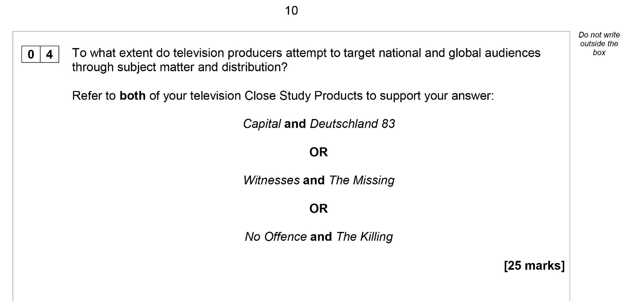
Media Studies
Assessment Feedback Sheet
Student Name
Assessment | A2 TV assessment
Date | January 2021
Mark Breakdown | /25

Assessment Objectives – AO1 1b, AO2 2 and AO2 3
- Demonstrate understanding of the theoretical framework of media (8 marks)
- Apply knowledge and understanding of the theoretical framework of media to evaluate academic theories (8 marks)
- Make judgements and draw conclusions (4 marks)
Level | Range | Description
5 | 21-25 | • Excellent and accurate knowledge of how industries target audiences  • Excellent and accurate understanding of the theoretical framework that is demonstrated by consistently appropriate explanation of attempts to target different audiences  • Excellent, astute judgements and conclusions that are consistently well supported by relevant examples from the set products.  • Consistent highly appropriate use of subject specific terminology throughout.
4 | 16-20 | • Good, accurate knowledge of how industries target audiences  • Good understanding of the theoretical framework that is demonstrated by frequent appropriate explanation of attempts to target different audiences  • Good judgements and conclusions that are often supported by relevant examples.  • Frequent appropriate use of subject specific terminology throughout.
3 | 11-15 | • Satisfactory, generally accurate knowledge of how industries target audiences  • Satisfactory understanding of the theoretical framework that is demonstrated by generally appropriate explanation of attempts to target different audiences  • Satisfactory judgements and conclusions that are sometimes supported by examples.  • Generally appropriate use of subject specific terminology throughout.
2 | 6-10 | • Basic knowledge of how industries target audiences.  • Basic understanding of the theoretical framework that is demonstrated by occasional appropriate explanation of attempts to target different audiences  • Basic judgements and conclusions that are generally unsupported by examples.  • Occasional appropriate use of subject specific terminology throughout.
1 | 1-5 | • Minimal knowledge of attempts to target different audiences  • Minimal understanding of the theoretical framework that is demonstrated by some basic explanation of how industries target audiences.  • Limited judgements and conclusions that lack reasoning and are unsupported by examples.  • Minimal use of subject specific terminology throughout.
0 | 0 | Nothing worthy of credit

Overall,
- Many thanks for completing this essay

To move to the next level you need to:
- Now you have completed this essay go back and revisit the blog post on this post and read it again – reflection and evaluation is a great tool to more consolidated learning.
- Watch your chosen TV episodes again
- Look at some other responses and compare them
- Make sure you look through the feedback suggestions below
- Keep thinking about these ideas in terms of the culture that you consume

Student Reflection & Actions:

Indicative content
Responses are required to make judgements and draw conclusions about the extent to which industries attempt to target national and global audiences They should refer to the television CSPs to support their points.
Responses in the higher bands will clearly engage with the ‘to what extent’ element of the argument and will support their points with effective reference to the CSPs. Responses in the middle band will show some engagement with this element of the question and use examples in a straightforward way to support conclusions. Responses in the lower bands may not engage with this element of the question, may not draw conclusions that are substantiated by reference to the CSPs, or may simply describe aspects of digital convergence and/or the set products.
As a synoptic question, the knowledge and understanding and judgement of the products should also allow candidates to draw on material from across the framework and media contexts. Responses in the higher bands must draw together elements across the course of study to inform their analysis and judgements (responses do not have to refer to all four areas of the theoretical framework and contexts of the media but should draw from a range of elements from across the course).
Media Language:
  - how the different modes and language associated with different media forms communicate multiple meanings
  - the codes and conventions of media forms and products, including the processes through which media language develops as genre
  - how audiences respond to and interpret the above aspects of media language
  - the way media language incorporates viewpoints and ideologies.
Representations:
  - the processes which lead media producers to make choices about how to represent events, issues, individuals and social groups
  - the effect of social and cultural context on representations
  - how audiences respond to and interpret media representations
  - the impact of industry contexts on the choices media producers make about how to represent events, issues, individuals and social groups.
Industries:
  - how media organisations maintain, including through marketing, varieties of audiences nationally and globally
  - the relationship of recent technological change and media production, distribution and circulation
  - processes of production, distribution and circulation by organisations, groups and individuals in a global context.
Audiences:
  - how audiences are grouped and categorised by media industries, including by age, gender and social class, as well as by lifestyle and taste
  - how media producers target, attract, reach, address and potentially construct audiences
  - how media industries target audiences through the content and appeal of media products and through the ways in which they are marketed, distributed and circulated
  - how specialised audiences can be reached, both on a national and global scale, through different media technologies and platforms
  - how media organisations reflect the different needs of mass and specialised audiences, including through targeting.
The CSPs can be used to discuss the targeting of national and global audiences.
Examples of the way institutions target national and global audiences could include:
  - ensuring that the content is relevant and interesting for a range of audiences across national borders (for example by addressing global themes and issues as well as culturally specific topics)
  - the mix of national and global in subject matter and settings suggests that part of the appeal of the TV series is the difference rather than the similarity to a particular culture
  - utilising the internet in order to create a ‘buzz’ about a product that can be accessed globally in an instant
  - using a variety of platforms that includes: free-to-air television, the internet (including subscription services such as Netflix), web apps, subscription services such as Sky
  - developing brand recognition through repeating genre, visual style, characterisation – including familiar actors, etc
  - • increased development of international co-productions as an industry strategy to address audiences across borders.

The following suggests a range of possible responses.
Answers are not expected to cover all the points and credit should be given to alternative, valid answers.
Note: There is no requirement to cover both Products equally or to be comparative.
Responses which fail to address both CSPs should not be awarded marks above the middle of Level 4 (18).

With reference to Capital (UK) and Deutschland 83 (Germany).
Capital (UK):
  - commissioned and originally broadcast by the BBC which gives the series brand identity internationally – particularly through its subsidiaries BBC America and BBC Worldwide
  - Kudos, the independent producer of the series, specialises in TV series which can be sold or remade for the US market, making it typical of contemporary media institutions which operate globally rather than nationally
  - Freemantle (international production and distribution company), Pivot TV (US) and BBC Worldwide all in deals to distribute the series globally
  - promoted in the UK as a ‘state of the nation’ event series
  - themes and setting are also constructed to appeal to an international audience: setting includes recognizable London iconography, familiar to an international audience from film and TV. Themes span the domestic and global – family melodrama, romance as well as reference to the economic crash, terrorism and migration
  - the series combines the national style of social realism with the generic conventions of the crime drama and the focus on a crime to be solved
  - multi-cultural, multinational cast of characters address an international audience with diverse cultural experiences.
Deutschland 83 (Germany):
  - distributed by Freemantle, a British production and distribution company, subsidiary of RTL media, a global company which is designed to target an international audience
  - it is a co-production of AMC Networks, SundanceTV (US) and RTL Television (German and American), positioning it to exploit the national and global market
  - AMC and RTL were able to develop the series in the context of new opportunities for distribution and exhibition – e.g. the Walter Presents platform in the UK, which is a subsidiary of C4, exploiting broadcast and digital opportunities
  - focuses on German – and European – history and politics
  - the cast of relative unknowns – even in the country of production – were still used to promote the series through the focus on young, visually appealing male and female leads
  - • themes and setting are constructed to appeal to an international audience through the familiar narrative tropes of an ‘innocent abroad’ and the “Romeo and Juliet” romance. The series is visually stylish using a familiar postmodern style which exploits the current popularity of retro styles in fashion and music
  - • exploitation of social media; part of the Sundance TV marketing strategy was the use of historical sliders, live tweeting of the programme by the actress who played the lead character, playlists of 1980s music linked to Spotify and through Twitter account.

With reference to Witnesses (Les Temoins, France) and The Missing (UK).
Witnesses (Les Temoins, France):
  - product of French public service broadcaster – France 2 – associated with quality, serious drama in continental Europe
  - France 2 were able to develop the series in the context of new opportunities for distribution and exhibition – e.g. the Walter Presents platform in the UK which is a subsidiary of C4, exploiting broadcast and digital opportunities. Series distributed in US, Australia, Europe
  - style, content and characters of the series deliberately designed to replicate international success of Nordic Noir in order to target audiences beyond the national
  - The Missing contains a mix of French regional, local identity with more familiar genre conventions and characters
  - the series was marketed using familiar (to national audiences) actors but focused on the familiar iconography of the thriller and horror aspects abroad
  - the postmodern, hyperreal style is fashionable; internationally recognizable and popular.

The Missing (UK):
  - subject matter is both nationally specific and deals with global issues
  - BBC Worldwide, as a powerful international institution, is able to target a global audience unrelated to the national audience
  - co-production between BBC and Starz as a means of addressing audiences and extending appeal across nations
  - the second series is promoted in the context of the existing popular brand which includes the popular thriller genre and distinctive storytelling based on time slip elements (product identity)
  - the cast is balanced to be familiar and different to both national and international audiences (familiar British and French TV and film stars)
  - themes and setting are constructed to appeal to an international audience: setting Europe and the Middle East. Themes span the domestic and global – family melodrama, fictionalised reference to recent wars and themes of immigration
  - conscious exploitation of global social media landscape to create both anticipation and ongoing interest (especially Twitter: 1000 tweets a minute).

With reference to No Offence (UK) and The Killing (Forbrydelsen, Denmark/Germany).
No Offence (UK):
  - the importance of targeting an audience beyond the national evident in Channel 4’s investment in online company TRX (The Rights Exchange) which aims to facilitate the sale of programmes abroad
  - No Offence is produced by AbbotVision, the independent producer of Shameless – which was successfully remade in the US – suggesting that the appeal to an international audience is a deliberate strategy
  - No Offence represents British national culture to a British audience – but this identity is also used as a selling point internationally through the appeal of difference
  - the series has a social realist aesthetic which is a recognizable national style but is also popular in Europe (evidenced in the popularity of social realist films in Europe)
  - No Offence was broadcast on France2 the public service broadcaster, to very high viewing figures; the perceived weakness of French broadcast TV provides opportunities for export.
  - the series’ focus on the detective narrative and crime drama is familiar and understood globally, the representation of the independent, female detective has proven popularity.
The Killing (Forbydelsen, Denmark/Germany):
  - co-production of Danish and German PSB companies (DK and ZDF) creates a more powerful transnational base, able to negotiate international deals
  - The Killing was designed to exploit the economic possibilities offered by an international/ global market (e.g. success of Wallander). The appeal of the series was extended through the production of American and Turkish versions
  - themes and setting are constructed to appeal to an international audience by integrating conventions of a successful US long form drama and the crime drama but providing difference through the Nordic Noir brand
  - the values of Scandinavian society, which focus on equality, are appealing to a national audience but also cosmopolitan, transnational audience
  - although unknown to the international audience, the series uses the promotion of the star (Sophie Grabol) to market the series
  - the character of Sarah Lund is a familiar detective stereotype and conforms to the concept of the celebrity detective
  - marketing of the series to the audience beyond the national was evident but had limited official social network presence (a Facebook page but no twitter account), but many fan blogs and forums engaged with the series. The Killing was promoted by the Danish tourist board and a great many unofficial tie-ins with fashion and lifestyle products.

