INTRODUCTION TO POSTMODERNISM

What is postmodernism?
Best answered: There is no single ‘postmodernism’; there are many ‘postmodernisms’

Postmodernism is collection of related artistic styles and philosophical ideas that attempts to explore and explain the complexities of the post-millennial world. It’s not one theory or style, more like “members of a loosely constituted and quarrelsome political party”, some who contradict each other.

What do they have in common?
As you can tell by the ‘post’, Postmodernism is both what happened after, and a reaction to Modernism. So… in order to understand what Postmodernism is, we have to first examine Modernism and its achievements and controversies.

Modernism was:
- an artistic and intellectual movement that began at the end of the 19th century. It continues a much older intellectual movement that some have called the ‘Enlightenment Project’;
- The Enlightenment was a period of intellectual and cultural revolution that began in the Renaissance. It was opposed to superstition and religion, and encouraged a rational view of the world based on maths and science. Quest: to find an abstract and objective truth that underpins reality
- Modernism (as an artistic style) continued the Enlightenment by celebrating the ‘modern’ industrial world that science and rationality created.
- It also was firmly against tradition – old architectural styles, ways of painting, methods of production etc were rejected as being obsolete.
- One way of seeing modernism’s attitude to the past is as ‘clutter’ – history was full of old ideas, theories and methods that had no relevance to the industrial world. Modernism rejected the ‘clutter’ in search of PURITY
e.g. in Modern art we can see the rejection of representational, figurative painting:
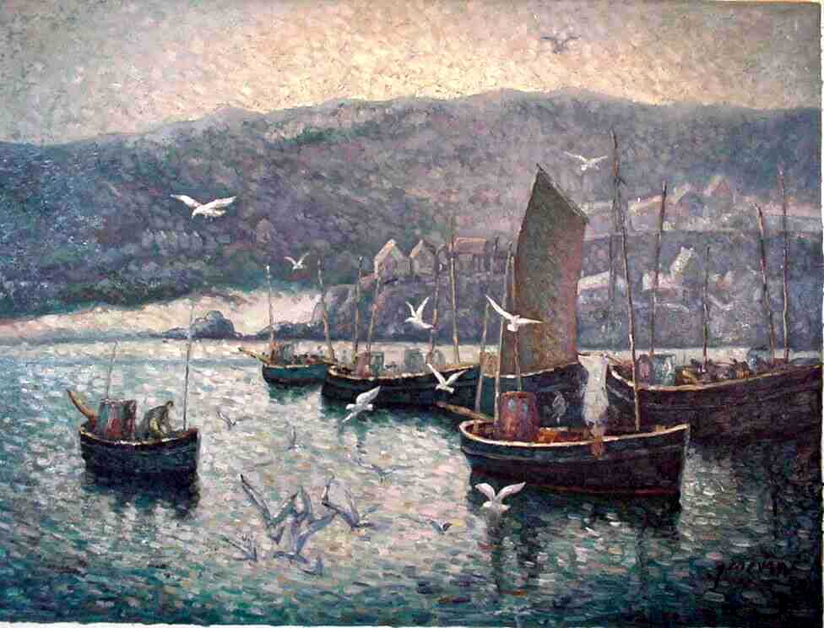
.with the search for abstract, ‘pure’ geometric forms:

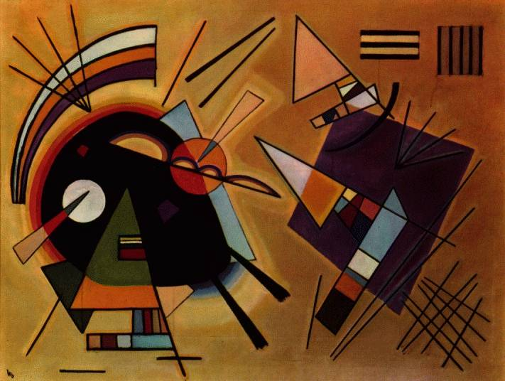

- In common with Science and Maths, Modernism also sought ultimate truth. It despised the subjective world where everyone’s viewpoint differed, and made its mission to find an objective, testable, provable reality (like Science).
- When modernism was an artistic trend, it was merely interesting and refreshing. When it was applied to politics and society, the results were catastrophic:

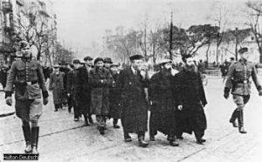

- The Modernist search for purity and ‘truth’ could be seen as an influence fascism and Nazism: their ‘truth’ was the historical and cultural superiority of the Aryan people; their quest for ‘purity’ was ethnic: society had to be ‘cleansed’ of those who didn’t fit the model of perfection. Some critics say modernism led directly to the Holocaust.
- Post-War, the world had another reason to be suspicious of the domination of science and maths: the atom bomb. For the first time, human beings had the power to extinguish their entire race. This created a profound insecurity and anxiety in Western societies, and a scepticism that scientific discoveries were part of human ‘progress’.

POST-MODERNISM
- There is no clear ‘movement’ in Postmodernism – it is a range of artists, writers, philosophers, critics etc. who all reacted in different ways against the singular, blinkered quest of modernism.
- In fact, DIFFERENCE is one of the key ideas in Postmodernism. Instead of trying to search for one, objective, rational truth, Postmodernism suggests that there isn’t ‘truth’ only many, many ‘truths’….
- It isn’t an outright rejection of the modern – it still deals with the complicated, technologically advanced world we live in. But due to the explosion of information technology, and the expanded view of the world it provides, we can’t say one viewpoint is ‘true’ or ‘right’ or ‘normal’ anymore, because there are so many individual viewpoints in the world that would contradict the single view. This is a return to the SUBJECTIVE.
- And... if there are multiple views of the world, multiple interpretations then… how can we say anything is objectively REAL? Postmodernism rejects all ideas of objective truth, right/wrong, good/bad, better/worse

Camille Paglia, the feminist writer and critic, said:
“Postmodernism is just shopping”
What she meant by this was that we now live in a world where we have access to a massive variety of different ideas, styles, beliefs, fashions, and we have the choice to pick and choose, mix and match them. We are also accustomed to capitalism where we are offered a huge range of products to buy. Paglia was saying we assemble our identity the same way we assemble an outfit.
What would be an optimistic view of this idea?
What would be a pessimistic view?

Task – look at the table of Modernist vs. Postmodernist concepts. Try to link the following examples to the concepts.
Modernism | Postmodernism
Rock music (values live performance, real instruments, ‘proper’ songs) vs. | Hip hop (‘live’ performance is just DJ and MC, no real instruments, constructed from samples of other songs)
U.S. Army | Al-Qaeda terrorist cells
Kate Moss as an ideal vision of beauty:  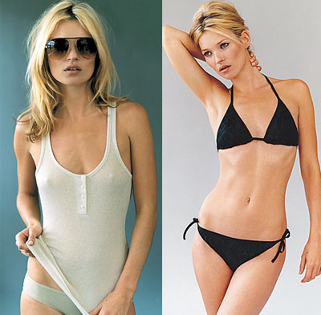 | Alison Lapper - the model for Marc Quinn’s sculpture of a disabled pregnant woman in Trafalgar Square.  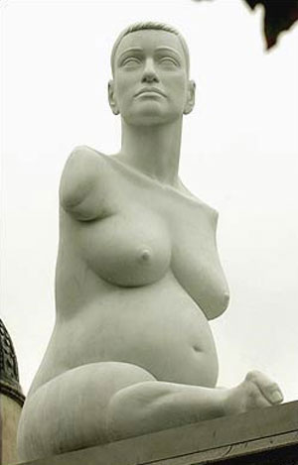
‘Macho’ man (i.e. embodies all traditional traits) | Heterosexual transvestite

Modernism vs Postmodernism

This chart is an edited version of the one available at: http://nmc.loyola.edu/intro/postmod/table.htm

The features in the table below are only tendencies, not absolutes. In fact, the tendency to see things in seemingly obvious, binary, contrasting categories is usually associated with modernism. The tendency to dissolve binary categories and expose their arbitrary cultural co-dependency is associated with postmodernism.

MODERNISM  - Using rational, scientific, logical means to know the world. Optimism that we can understand and control an objective world | POSTMODERNISM  - A reaction against rationalism, scientism, or objectivity of modernism.
- There is an absolute, universal truth that we can understand through rationalism and logic. | - There is no universal truth. Rationality by itself does not help us truly understand the world.
- Humans are material machines. We live in a purely physical world. Nothing exists beyond what our senses perceive. | - Suspicious of such dogmatic claims to knowledge.
- Humankind is progressing by using science and reason. | - "Progress" is a way to justify the domination by European culture of other cultures.
- Time, history, progress | - Culture on Fast Forward: Time and history replaced by speed, accelerated obsolescence. The next idea isn’t necessarily ‘better’ than the last.
- history as a "narrative of what happened" with a point of view and cultural/ideological interests. | - Postmodern historians and philosophers question the representation of history and cultural identities: history as "what 'really' happened" is from one group's point of view
- Faith in "Depth" (meaning, value, content, how things work) over "Surface" (appearances, the superficial, how we use things). | - Attention to play of surfaces, images, things mean what we make them mean, no concern for "depth" but with how things look and respond
- "disenchantment with material truth and search for abstract truth." | - "There is no universal truth, abstract or otherwise."
- Faith in the "real" beyond media and representations; authenticity of "originals" | - Hyper-reality, image saturation, simulacra seem more powerful than the "real"; images and texts with no prior "original".  "As seen on TV" and "as seen on MTV" are more powerful than unmediated experience.
TIME LINE  - (Renaissance?) Enlightenment > 1750s > 1890-1945. | - Post WWII, especially after 1968
GENERAL  - Attempt to acheive a unified, coherent world-view from the fragmentation that defines existence | - Attempt to overturn the distinction between "high" and "low" culture
- High Modernism 1920s & 1930s, following WWI -- outmoded political orders and old ways of portraying the world no longer seemed appropriate or applicable; reaction against existing order | - Eclecticism, a tendency toward parody and self-reference, and a relativism that knows no ultimate truth; no distinctions between "good" and "bad"
- Classification of the world; order; hierarchy | - The way we understand the world is relative; it depends on our culture, position, class, gender, age, time period, beliefs, etc.
- Mastery and progress Historical development; past affects present and future. Universalizing Linear (like a novel) Works of art, science are windows to the truth. | - "Localizing", pluralizing. Non-linear (like the Web) Works of art, science are only texts, can only be understood by referring to their own systems of meaning.
CULTURE  - High culture vs. low culture -- strictly divided; Only high culture deserves to be studied, analyzed | - Everything's "popular" culture -- it all deserves to be studied; pluralizing. Commodification of culture -- everything can be bought or sold
- Humans are self-governing and free to choose their own direction | - People are the product of their culture and only imagine they are self-governing.
- reality can be discovered through science and can be expressed abstractly (equations) | - "the transformation of reality into images" (Britney Spears is not a person but an image; Nike is not about shoes but about an image, etc.)
- Mass culture, mass consumption, mass marketing. | - Demassified culture; niche products and marketing, smaller group identities.
SYMBOLISM  - Symbols & meaning: hammer and sickle = world communism | - Symbols drained of meaning: hammer and sickle in advertising (e.g., beer commercials)
BODY  - Clear dichotomy between organic and inorganic, human and machine | - cyborgian mixing of organic and inorganic, human and machine and electronic
POLITICS  - Big ideas/big, centralized political parties rule | - Fragmented ideas, decentralized power; "micro-politics": interest groups rule (minority factions, NRA, business groups); Foucault, "everyone has a little power" TV politics -- clash of images: "how will it play on the six o'clock news?"
IDENTITY  - Sense of unified, centered self; "individualism," unified identity. | - Sense of fragmentation and decentered self; multiple, conflicting identities. Schizophrenic.
ARTS  - Artist is creator rather than preserver of culture. Impressionism, Cubism, abstract expressionism. "Photograph never lies" -- photos and video are windows/mirrors of reality | - Artist plays with different styles; aesthetics; pastiche all-important. Pop Art, Dada, montage
- Art fights capitalism | - Photoshop: photos and video can be altered completely (where's the reality?) Art is consumed by capitalism
- Art as unique object and finished work authenticated by artist and validated by agreed upon standards. | - Art as process, performance, production, intertextuality. Art as recycling of culture authenticated by audience and validated in subcultures sharing identity with the artist.
- Art as one unique object created by a master artist.  Analog media: quality deteriorates the farther removed a copy is from the original | - Art as copies (Andy Warhol's Factory)  Digital media: there is no distinction between an original and a copy
- Seriousness of intention and purpose, middle-class earnestness. | - Play, irony, challenge to official seriousness, subversion of earnestness.
- Sense of clear generic boundaries and wholeness (art, music, and literature). | - Hybridity, promiscuous genres, recombinant culture, intertextuality, pastiche.

Using the above to guide us, how could we use postmodernism to help us to understand the following on-line media phenomenon?

- YouTube videos

- Citizen journalism

- ‘Techno Cottage Industries’ e.g. ‘bedroom’ producers distributing their music through MySpace

- News blogs

- Wikipedia

- Second Life

